Cells that make up bones | - Three types of cells that make up bone are osteoblasts, osteocytes, and osteoclasts  - Osteoblasts are responsible for laying down new bone; they are immature bone cells that produce the bone matrix (aka osteoid), which later harden through ossification (the process by which bone is formed)  - Hemopoiesis is responsible for forming the bone marrow  - Osteoclasts destroy bones; they are large multinucleated cells that are capable of dissolving bone matrix (osteolysis/resorption)  - Osteocytes are osteoblasts that are trapped in ossified matrix inside cell-like lacunae and surrounded by bone
Classification of bones by shape | - Long bones: Primarily grow thru lengthening of the diaphysis (shaft), which has two rounded ends (epiphyses) and a marrow/medullar cavity (e.g. radius, femur)  - Short bones: No medullar cavity (e.g. carpal)  - Flat bones: Thin horizontal bones formed from two layers of compact bone w a middle layer of cancellous bone (e.g. skull bones, pelvis, ribs, scapula)  - Pneumatic bones: Have an air-filed cavity (e.g. sinuses)  - Sesamoid bones: Small, short bones of an irregular spherical or sesame seed like shape that alleviate some of the stress caused by friction on joints or tendons (e.g. patella)  - Irregular bones: Irregular shapes (e.g. hip bones, vertebrae)
Classification of bone tissue | - Compact bones: Provides structural strength, allows movement and weight bearing; composed of tightly grouped osteons (aka haversian systems)  - Each osteon is comprised of a solid matrix of osseous lamellae surrounding a central canal containing blood vessels that nurture the bone  - Osteocytes are bw the lamellar rings inside lacunae  - Canaliculi (channels) extend from lacunae to the haversian canal—nutrition is brought in thru the canaliculi and was is removed out  - Cancellous/spongy/trabecular bones: Protects bone marrow and provides internal structural support; found inside and at the end of rounded ends of long bones, pelvis, and breast bones  - Honeycomb appearance w trabeculae (the bony ridges w/in honeycomb), which provides support against strength and can change shape as result of it; trabecular spaces filled w red marrow where blood is produced  - Trabeculae is made up of bone or collagen (a connective tissue made up of fibrous proteins)  - Nutrition received not thru haversian systems but thru canaliculi
Bone conditions | - Osteomalacia: Softening of bones  - Osteopetrosis: Hardening of bones  - Osteoporosis: Weakening and brittling of bones  - Multiple myeloma: Collection of abnormal cells that accumulate within bones
Periosteum  Endosteum | - Periosteum: Membrane that covers the outer surface of bones except for their articular or joint surfaces  - Endosteum: Lines the hollow interior surfaces bones; contains osteoblasts
Peritoneal  Retroperitoneal | - Peritoneal: Space within the abdomen that contains most of the abdominal organs  - Peritoneum is the thin membrane in the abdominal cavity that covers the abdominal organs and lines the abdominal cavity  - Retroperitoneal: Behind the parietal layer of peritoneum; outside the abdominal cavity proper (e.g. kidneys are located retroperitoneal to the abdominal cavity)
Connective tissue - Density | - Several types of connective tissue differ based on the type of extracellular matrix in which it belongs  - In increasing order of density: blood, hemopoietic tissue, areolar tissue, adipose tissue, fibrous connective tissue, cartilage, bone
Hemopoietic tissue | - Connective tissue that forms the bone marrow within long bones  - Also responsible for formation of blood
Gluco- vs. Glycogenesis | - Glycogenesis: Process of glucose absorbed from the GI tract stored in the liver as glycogen  - Gluconeogenesis: Process of glucose being made in the liver from amino acids  - Ketosis: Depleted amount of glycogen in the liver; a metabolic disorder common in dairy cows during early lactation, caused by an energy deficit that forces the body to break down fat, producing toxic ketone bodies
Fatty acid synthesis | - Initial process of converting glucose into fat
Erythropoietin | - Hormone that stimulates the red bone marrow to increase production of oxygen-carrying RBCs  - Produced by kidneys when the kidneys detect hypoxia (oxygen deprivation) in the blood
Diabetes insipidus | - Caused by a deficiency in antidiuretic hormone (ADH)  - Leads to production of large quantities of very dilute urine and drinking of large quantities of water  - Treated by administering a drug with ADH activity for the rest of the animal's life
Diabetes mellitus | - Caused by a deficiency in the hormone insulin, which means glucose doesn’t move into the cells  - Can be fatal if left untreated  - Can cause polyuria, polydipsia, polyphagia, tachypnea, weight loss, weakness, depression, vomiting  - Insulin overdose can cause hypoglycemia (weakness, lethargy, seizures)  - UTI is a common secondary complication in cats and dogs w diabetes mellitus (also chronic kidney disease and hyperadrenocorticism)  - Lab tests show hyperglycemia (too high glucose) and glycosuria  - Weight control and consistent food dose is important; semi-moist food not recommended due to higher sugar and lower fiber content
Veins | - Azygous vein: Drains venous blood from the thoracic body wall  - Jugular vein: Drains blood from the head  - Iliac vein: Drains blood from the hind limbs  - Hepatic veins: Drain blood from the liver
Facet | - A flat articular surface found on many bones  - Does not allow passage of nerves or blood vessels (vs. meatus, sinus, and foramen, which consist of holes or channels that allow passage)
Estrus cycle | - Proestrus: Attracts male but not receptive; FSH induces ovarian follicles to develop estrogen, which then induces endothelium to grow and form an inner layer in the uterus in preparation of a fertilized egg to implant  - Estrus (standing heat): Period of sexual receptivity; release of LH from pituitary causes ovulation in dogs, while cats and rabbits are induced (nonspontaneous) ovulators  - Metestrus: Ruptured follicles develop into corpus luteum, which produce progesterone which inhibits new follicle development  - Diestrus: Corpus luteum degenerates if no pregnancy occurs; remaining at this stage (exaggerated diestrus) results in pseudocyesis or pseudopregnancy  - Anestrus: Long period of ovarian inactivity in seasonally polyestrous animals
RR | - Breaths per minute:  - Dog: 16 – 32  - Cat: 20 – 42  - Horse: 8 – 16  - Cattle: 12 – 36  - Swine: 32 – 58  - Sheep: 16 – 34  - Llama: 12 – 30  - Hedgehog: 25 – 50  - Ferret: 33 – 36  - Mouse: 80 – 230  - Avian: 20 – 60
HR | - Beats per minute:  - Dog: 60 – 160 // 70 – 120  - Cat: 140 – 220 // 120 – 140  - Horse: 28 – 50 // 28 – 40  - Cattle: 40 – 80  - Swine: 70 – 120  - Sheep/Goat: 70 – 80  - Llama: 60 – 90  - Rabbit: 180 – 350  - Hedgehog: 180 – 280  - Ferret: 200 – 400  - Mouse: 450 – 750  - Avian: 100 – 300
Temperature | - Fahrenheit:  - Dog/Cat: 100 – 102.5  - Puppy/Kitten: 100  - Cattle: 100.4 – 103.1  - Horse: 99.5 – 101.5  - Ferret: 100 – 104  - Hedgehog: 97.9 – 99.3  - Rabbit: 101 – 104
Mentation | - Mental activity or level of consciousness; should be documented for each patient  - Normal: Bright, alert, responsive to stimuli/surroundings  - Dull: Interactive by nudging or walking up, depressed but interested in people  - Obtunded: Reactive to stimuli but not interested, slower moving, more depressed  - Stuporous: Disconnected, only responsive to painful stimuli  - Unresponsive: No response to any stimuli
Blood | - Make up 7% of body weight  - Whole blood: Blood in the cardiovascular system  - Peripheral blood: Whole blood circulating in blood vessels
Blood composition | - Cellular components: RBCs, WBCs, platelets (thrombocytes)  - Plasma: All components of blood minus cells; made up of 91% water, 7% proteins, 2% others; clear liquid at the top if blood w anticoagulant is left to sit and components settle  - Buffy coat: Layer of WBCs and platelets between the top plasma and bottom RBC layers  - Serum: Blood after blood cells and clotting factors (i.e. fibrinogen proteins) are removed; fluid that rises to the top when blood is centrifuged with no anticoagulant; forms a larger percentage of blood than plasma
Blood vessels | - Arteries (arterial vessels): Carry blood away from the heart; oxygenated blood except for pulmonary artery; thicker/stronger than veins and with more pressure; aorta is the main, leaving the heart at the left ventricle, subclavian artery is a branch of the aorta that supplies blood to the cranial portion of the body into the forelimbs, carotid artery is the branch traveling up the neck, celiac artery supplies the stomach  - Arterioles: Small arteries that lead to capillaries  - Capillaries (smallest arteries): Site of carbon-dioxide/oxygen exchange; microscopic diameter w one layer of endothelium; porous so substances can move freely bw extracellular fluid and blood  - Venules (smallest veins): Emerge from capillaries and enlarge into veins  - Veins (venous vessels): Carry blood back to the heart; carry deoxygenated blood other than the pulmonary vein; larger than arteries w thinner walls and lower pressure; backflow is prevented by valves; largest two are the vena cavas
Anterior (cranial) vena cava | - The major vein returning deoxygenated blood from the head, neck, forelimbs, and front chest to the heart's right atrium  - Formed by the brachiocephalic veins
Posterior (caudal) vena cava | - The major vein returning deoxygenated blood from the hindquarters and abdomen to the heart  - Crucial for assessing hydration, cardiac function, and diagnosing issues like thrombi (clots) or congenital anomalies
Hepatic portal vein | - The vein that drains blood from the stomach, intestine, and pancreas and flows directly to the liver  - Takes blood straight from the digestive tract to the liver so that the product of digestion can be processed immediately  - Liver also receives blood from the hepatic artery (branch of celiac artery)  - Both veins go into the liver at the “triads”
Vena cavas | 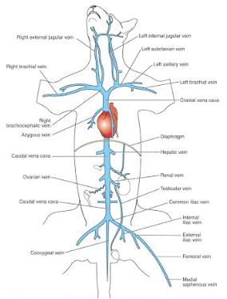
Blood pressure | - Systole: Contraction of heart muscles resulting in blood being ejected from the atria to the ventricles and then to the arteries (both atria and ventricles contract)  - Diastole: Relaxation of heart muscles that allow chambers to fill w blood (both atria and ventricles relax)  - Systolic BP: Force exerted by blood on the vessel walls during contraction of the ventricles (maximum)  - Systolic arterial BP is created when the left ventricle contracts and blood is pushed into the aorta  - Diastolic BP: Force exerted by blood on the vessel walls while ventricles are relaxed (minimum)  - Diastolic arterial BP is when the left ventricle empties and relaxes  - Mean arterial pressure (MAP): DAP + 1/3 (SAP – DAP)
BP measurement | - Direct measurement by using an arterial catheter  - Indirect measurement by using a Doppler ultrasound (sphygmomanometer; gives SAP for dogs, MAP for cats)  - Indirect measurement through oscillometric reading (cuff width of 40% of limb circumference in dogs and 30% in cats; gives SAP, DAP, MAP)  - Normal systolic BP for cats is 120-160 mmHg (millimeter of mercury)
Seminiferous tubules | - Site of sperm cell (spermatozoa) production (i.e. spermatogenesis)  - Spermatozoa is later stored and mature in the epididymis, a flat ribbon-like structure that lies along the surface of the testes, connecting the efferent ducts of the testes with the vas deferens  - Sperm cells travel through the vas deferens (ductus deferens), a tube-like structure that connects the tail of the epididymis with the pelvic portion of the urethra (VD propels spermatozoa and fluid from the epididymis to the urethra)  + Seminal vesicles are a pair of smooth-surfaced, pear-shaped glands located on either size of the bladder and considered an accessory gland for production of seminal fluid; dogs and cats do not have them
Leukocytosis | - An increase in WBCs  - vs. leukopenia; decrease in WBCs
Thrombocytopenia | - Low blood platelet count  vs. thrombocytosis (an elevated number of platelets)  - Patients may experience bleeding when inadequate numbers of platelets are available to form a platelet plug  - Signs include petechiae, ecchymoses, and anemia  - Can be caused by hemorrhage, rodenticide poisoning, immune-mediated, med side effect, neoplasms, infectious agents like babesia, toxoplasma, FELV, FIP, FIV  - Less than 100,000 μL is a red flag in mammals
Functions of the lymphatic system | - Removal of excess tissue fluid (inadequate drainage can cause edema)  - Waste material transport  - Filtration of lymph (happens as lymph passes through lymph nodes)  - Lymph starts out as excess tissue fluid and contains mostly lymphocytes, proteins, fats, and hormones  - Protein transport (large proteins like enzymes are transported in lymph because they are too big to enter venous circulation)
Lymph organs | - Spleen: Largest single mass of lymphoid tissue; produces lymphocytes, stores and releases blood, and has phagocytic function  - Tonsils: Embedded in the mucous membrane  - Thymus: Located in the cranial chest cavity bw trachea and ribs; important in developing immune response in the young and replaced by fat in adults  - MALT: Mucosa-associated lymphatic tissue; found in mucosal linings throughout the body (e.g. Peyer patches)
Turbinates | - Four, thin, scroll-like bones that fill most of the space in the nasal cavity  - Shape forces inhaled air around many twists, warming and humidifying it and trapping foreign material in the moist surface of the nasal epithelium  - A dorsal and a ventral turbinate on each side  - Also called the nasal conchae
Interosseous space | - Located bw the radius and ulna of the horse
Epaxial and hypaxial muscles | - Epaxial muscles lie dorsal to the transverse process of the vertebrae  - Hypaxial muscles lie ventral to the transverse process of the vertebrae
Flagella | - Long structures that propel cells through fluid; vs. cilia, which move fluid across cell surfaces  - Both cilia and flagella originate from a pair of centrioles called basal bodies
Vertebral formulas | - Cervical-Thoracic-Lumbar Sacral Caudal/Coccygeal  - Dog: 7-13-7 3 6 to 23  - Cat: 7-13-7 3 6 to 23  - Horse: 7-18-6 5 15 to 20  + Sacral vertebrae are unique in that they fuse to form a single, solid structure called the sacrum
Joints | - Skeletal articulation; found wherever bones come together for movement  - Formed where bones are united by fibrous, elastic, or cartilaginous tissue  - Synarthrosis: Immovable; united by fibrous tissue; no joint cavity; e.g. suture joints of the skull  - Amphiarthrosis: Slightly movable; cartilaginous tissue (united by cartilage); no joint cavity; e.g. intervertebral discs or pubic symphysis  - Diarthrosis: Movable; joint cavity filled with synovial fluid; e.g. shoulder
Synovial joints | - Hinge (ginglymus) joints: One joint surface swivels around another; only flexion and extension possible (e.g. elbow)  - Gliding (arthrodial) joints: Rocking; mainly flexion and extension (for most 4-legged animals), but also some abduction and adduction too (e.g. carpus)  - Pivot (trochoid) joints: One bone rotates around the other; only movement is rotation—only atlantoaxial joint b/w 1st and 2nd cervical vertebrae  - Ball and socket (spheroidal) joints: Most extensive movement (flexion, extension, abduction, adduction, rotation, circumduction) (e.g. shoulder and hip)
Synovial joint movements | - Flexion: Decreases angle between two bones (e.g. picking a horse’s foot for an exam flexes the carpus joint)  - Extension: Opposite movement that increases the angle (e.g. straightening a bent (flexed) elbow joint)  - Adduction: Movement of an extremity toward the median plane  - Abduction: Movement of an extremity away from the median plane  - Circumduction: Movement of an extremity so that the distal end moves in a circle
Anterior drawer movement | - Abnormal forward-backward movement of the femur and tibia relative to each other  - Used to diagnose cranial cruciate ligament (CCL) rupture, which leads to instability in the stifle joint (starts to slide forward and backward instead of the normal hinging)
Altricial | - Hairless, deaf, and blind newborn rabbits  - Totally dependent on mother for a few weeks
Hyoid apparatus | - Structure that suspends the larynx from the skull  - Hyoid bone supports the base of the tongue, the pharynx, and the larynx, and aids the process of swallowing; it is attached to the temporal bone by cartilage
Vagus nerve | - Cranial nerve X  - Longest cranial nerve in the body; innervates many organs  - Provides sensory function for the GI tract and respiratory tree; provides motor functions for the larynx, pharynx, parasympathetic, abdominal, and thoracic organs  - During emergency intubation, it may be stimulated to increase vagal tone, causing bradycardia
Cranial nerves | CN I—Olfactory: Smell (sensory)  CN II—Optic: Vision (sensory)  CN III—Oculomotor: Eye movement, pupil size, focusing of the lens (motor)  CN IV—Trochlear: Eye movement (motor)  CN V—Trigeminal: Sensations from head and teeth, chewing (sensory/motor)  CN VI—Abducent: Eye movement (motor)  CN VII—Facial: Face and scalp movement, salivation, tears, taste (sensory/motor)  VIII—Vestibulocochlear: Balance, hearing (sensory)  IX—Glossopharyngeal: Tongue movement, swallowing, salivation, taste (sensory/motor)  X—Vagus (wanderer): Sensory from GI tract and respiratory tree, motor to the larynx, pharynx, parasympathetic, abdominal/thoracic  XI—Accessory (w vagus): Head movement (motor)  XII—Hypoglossal: Tongue movement (motor)
Muscle tissue | - Skeletal muscle:  - Striated, multiple nuclei located at the periphery  - Voluntary control; attaches to and moves bones  - Smooth muscle:  - Spindle-shaped cells w a central nucleus  - Involuntary control; forms walls of hollow organs inc. blood vessels; no bony attachments  - Cardiac muscle:  - Long, striated cells w a central nucleus; joined at “intercalated discs”  - Involuntary control  - Only in the heart
Endomysium  Epimysium | - Endomysium: Connective tissue membrane that surrounds each muscle fiber  - Epimysium: Connective tissue membrane that covers and defines the entire muscle
Cytoplasm | - Everything within the cell except the nucleus  - Include cytosol (gel-like fluid inside the cell), organelles like ribosomes, mitochondria, etc., and cytoskeleton
Vaginal tunic | - The two layers of connective tissue that surround the testes in the scrotum and spermatic cord  - The thick outer layer is called the parietal vaginal tunic  - The thin inner layer is called the visceral (proper) vaginal tunic  - Parietal refers to the outer layer lining a body cavity, while visceral refers to the inner layer that covers the organ itself
Hilum | - Indented area on the medial side of the kidney  - Where blood vessels, nerves, and ureter enter and leave the kidney  - The renal artery branches off the abdominal aorta and enters the kidney at the hilum  - The renal vein leaves the hilum of the kidney to enter the vena cava
Muscles | - Fixators: Muscles that provide support to joints  - Agonist: Muscle that is the primary producer of a movement  - Synergist: Muscle that assists the agonist in movement  - Adductor: Muscle that draws the body part toward the median line  - Abductor: Muscle that moves the body part away from the median line
Muscles moving the mouth | - The masseter muscle and temporalis muscle close the jaw  - The digastricus muscle opens the jaw  - The medial and lateral pterygoids are responsible for side-to-side movements of the mouth
Dental pad | - A flat, thick, connective-tissue structure on the maxilla of ruminants  - Opposite the lower incisors and canine teeth; takes the place of the upper incisors or upper canine teeth which ruminants don’t have  - Ruminants rely on high concentrations of sodium bicarbonate and phosphate buffers in their saliva to neutralize acids formed in the rumen
Organs of the endocrine system | - Pancreas  - Kidneys  - Stomach  - Small intestine  - Ovaries  - Testis  - Pituitary gland  - Thyroid gland  - Parathyroid gland  - Adrenal gland  - Thymus  - Pineal body  - Placenta
Pancreas | - Both an exocrine and endocrine gland  - Secretes substances outside the body and produces hormones that are secreted directly into the blood without traveling through a duct  - Main endocrine cells of the pancreatic islets (islets of Langerhans) are alpha cells, which produce glucagon, beta cells that produce insulin, and delta cells that produce somatostatin  - Dietary indiscretion, especially high-fat meals, is a common trigger for pancreatitis in dogs; blunt force trauma, pancreatic hypoperfusion (inadequate delivery of oxygen and blood), and pancreotoxic drugs are triggers for pancreatitis in dogs and cats
Spleen | - Left side of the abdomen near the stomach/rumen  - Stores RBCs, filters blood and lymph, and is capable of hematopoiesis (production of all blood cells, which mainly takes place in the liver)
Liver | - Largest organ in the abdominal cavity; immediately caudal to the diaphragm  - Functions include digestion, nutrient absorption and regulation of their release into the bloodstream, excretion, and producing most plasma proteins, cholesterol, and many blood coagulation factors  - Largest digestive gland; considered extramural gland (along with pancreas) meaning it’s outside the lumen of the GI tract
Insulin vs. Glucagon | - Insulin lowers blood glucose levels by causing glucose, amino acids, and fatty acids in the bloodstream to be absorbed by cells to be used for energy; released in response to elevated blood glucose levels; essential for life  - Glucagon raises blood glucose levels (hyperglycemic effect) by stimulating liver cells to convert glycogen (stored version of glucose) to glucose and by stimulating glucogenesis (i.e. conversion of fat and protein breakdown products to glucose)  - Glucagon deficiency isn’t too problematic since other hormones also have hyperglycemic effects
Mesovarium  Mesosalpinx  Mesometrium | - Each broad ligament has segments that are named according to the organ they directly support within the female reproductive tract  - Mesovarium supports the ovary  - Mesosalpinx supports the oviduct  - Mesometrium supports the uterus
Senses | - Proprioception is part of the general senses; senses body position and movement  - Taste, hearing, equilibrium, smell, and vision are special senses
Chyle | - Lymph from the digestive system  - After a meal, it contains microscopic particles of fat (chylomicrons) that cause the lymph to appear white or pale yellow
Parts of the ear | - Outer ear: Pinna, Auditory canal, tympanic membrane  - Middle ear: Ossicles (malleus, incus, stapes or hammer, anvil, stirrup)  - Inner ear: Cochlea, semicircular canals  - Liquid in inner ear helps w balance
Sound | - Sound is transmitted from outer via the middle ear’s ossicles, which vibrate to amplify and relay sound waves from the eardrum to the inner ear  - Hair cells in the cochlea of the inner ear moves in response to sound waves, generating auditory nerve impulses  - Corti, principal section of the cochlea, translates neural impulses to sounds
Ear parts in detail | - Pinna: Outer portion of the ear seen from the outside; a cartilaginous funnel that collects sound waves and directs them medially into the external auditory canal  - Eustachian tube: Connection of the middle cavity (middle ear) to the pharynx (connect middle ear to nasal cavity)  - Tympanic membrane: Ear drum; air-filled middle ear cavity; transmits vibrations to the inner ear  - Ossicles: Bones of the middle ear that transmit vibrations to the cochlea (malleus/hammer, incus/anvil, stapes/stirrup)  + Columella bone: Middle ear bone in birds, amphibians, and reptiles; transmits sound to the inner ear  - Cochlea: Snail-shaped, fluid filled cavity in the temporal bone of the skull; contains the hearing portion of the inner ear; absorbs vibrations of the sound waves
Trochlear notch | - Trochlea are bony structures through which tendons pass; they allow tendons to act as pulleys  - Trochlear notch is a large depression in the upper extremity of the ulna that fits the trochlea of the humerus  - Anconeal process is a beak-shaped process located at the proximal end of the trochlear notch
Aponeurosis | - Broad sheets of fibrous connective tissue that attaches some muscles to bones or other muscles (tendons attach most skeletal muscles to bones, aponeurosis is an exception)  - Most prominent aponeurosis is the linea alba (white line) that runs between the muscles on the ventral midline and connects the abdominal muscles; extends from the xiphoid process to the cranial brim of the pubis
Common bone features | - Articular surfaces: Joint surfaces; smooth areas of compact bone covered w smooth, thin layer of articular cartilage (a hyaline cartilage); include condyles, heads, facets  - Processes: Sites where tendons attach; can be called something process, or trochanter (femur), tubercle (humerus), tuberosity (ischium), spine (scapula), crest (tibia), wing (atlas)  - Holes and depressed areas: Holes are foramina w nerves or vessels passing through (e.g. mental foramen is an opening located on the mandible bone); fossas are depressed areas occupied by muscles or tendons
Ligament  Tendon | - Tendon: Attaches muscles to bones  - Ligament: Attaches bones to bones
Epiphysis  Diaphysis | - Epiphysis: Either end of the long bone  - Diaphysis: Shaft of the bone  - Epiphyseal (growth) plates: Most bones develop by endochondral bone formation, meaning they start as a cartilage template that is then replaced by bone (mostly by birth); two areas of a long bone remain as cartilage—bw diaphysis and epiphyses—which allows bone lengthening during growth (new cartilage is created on the epiphyseal surface and replaced w bone by osteoblasts in the diaphyseal surface) and ossifies when bone reaches full size
Processes | - Includes all lumps, bumps, and other projections on a bone  - Condyles are on the distal end of the humerus and femur and on the occipital bone of the skull  - Heads are found on the proximal ends of humerus, femur, and ribs  - Tuberosity is a rough projection on a bone (e.g. maxillary tuberosity)  - Greater trochanter is a process on the lateral part of the proximal extremity of femur  - Wing is a transverse process on the first cervical vertebrae
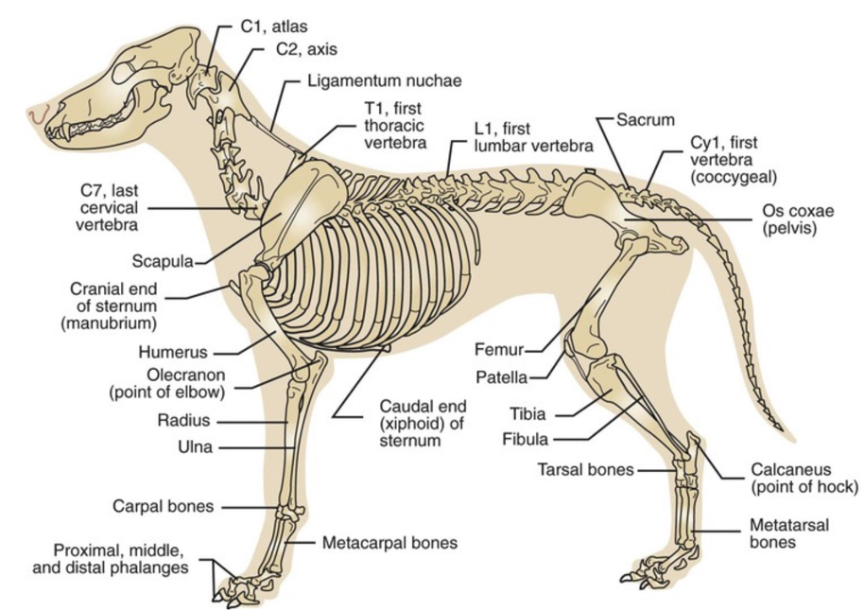 | 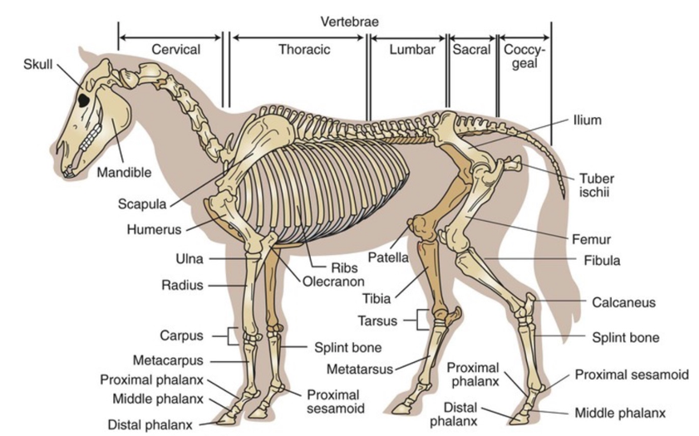
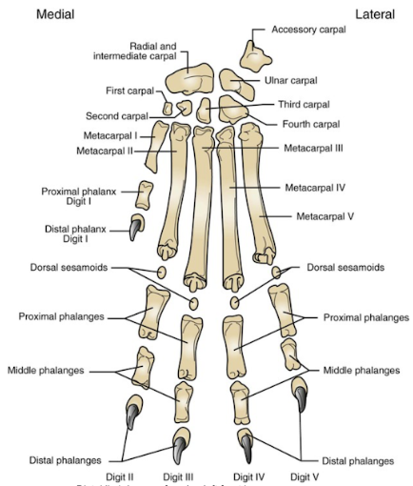 | 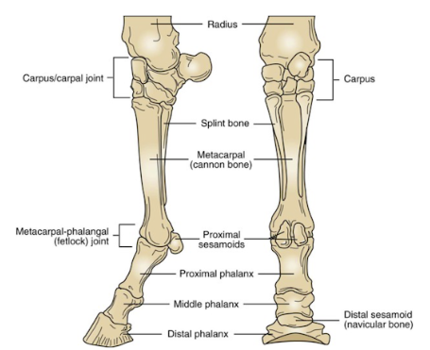
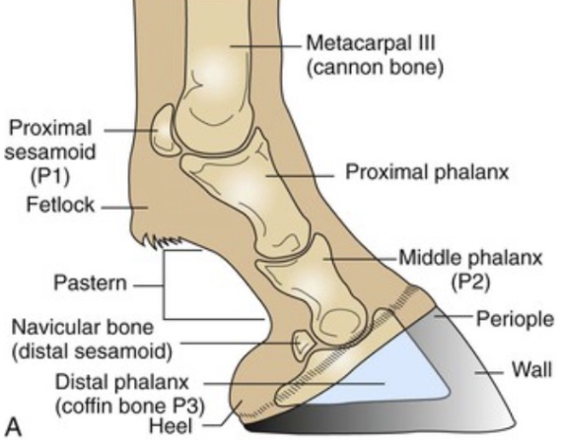 | - Equine hoof is divided into wall, sole, and frog  - Wall: Convex, external portion divided into toe, quarters, and heels  - Sole: Plantar surface; thin strip called white line is formed at the junction of sole and hoof wall  - Frog: Insensitive; triangular and horny structure w point/apex facing the toe and a centraldepression known as central sulcus or cleft
Anatomical planes | 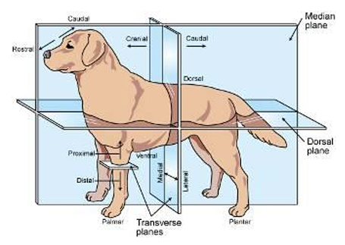
Anatomical planes  (Planes of reference) | - Dorsal plane: Divides body into upper and lower halves (dorsal and ventral portions) (think as if animal is standing in water)  - Sagittal plane: Runs the length of the body and divides it into left and right parts that aren’t necessarily equal  - Median plane: A special kind of sagittal plane that divides the body longitudinally into symmetrical left and right halves  - Transverse planes: Divides body into cranial and caudal portions or distal and proximal portions that aren’t necessarily equal
 | 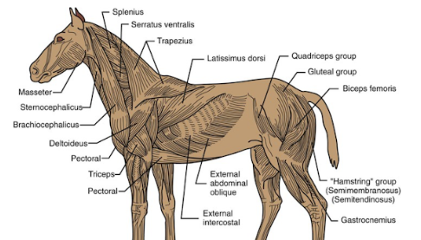
Skull bones (external bones of the cranium)  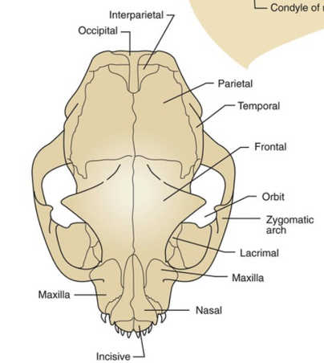 | - Interparietal bones (2): Located on the dorsal midline b/w occipital bone and the parietal bones; visible in young animals, fuse together to parietal bones when older  - Occipital bone: Forms the caudoventral portion (base) of the skull where spinal cord exits and skull articulates w the first cervical vertebra; most caudal skull bone  - Parietal bones (2): Form the dorsolateral walls; relatively small in horses and cattle  - Temporal bones (2): Below/ventral to parietal bones; form lateral walls of the cranium, contain the middle and inner ear structures, and form the TMJs with the mandible  - Frontal bones: Form the forehead/rostrolateral portion; contains the the paranasal sinus, frontal sinus
External (landmark) bones of the face  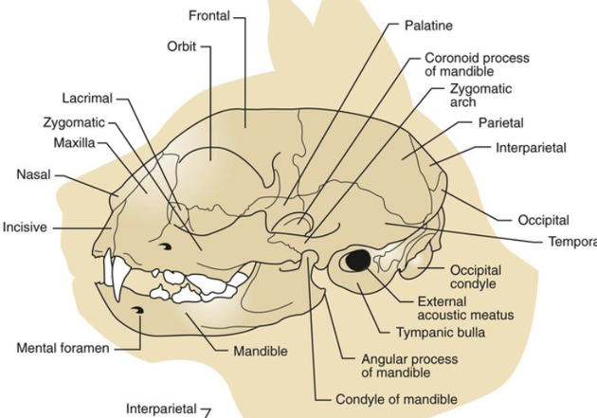 | - Incisive (premaxillary) bones (2): Most rostral skull bones; house the upper incisors if animal has them  - Nasal bones (2): Form the bridge of the nose; size depends on breed/species (e.g. whether brachy- or dolichocephalic)  - Maxillary bones (2): Make up the upper jaw along w incisive bones; house upper canines, cheek teeth, and maxillary sinuses; form the hard palate along w palatine bones (roof of the mouth)  - Lacrimal bones (2): Form part of the medial portion of eye’s orbit; houses lacrimal sac  - Zygomatic (malar) bones (2): Form part of the orbit  - Mandible: Lower jaw; only movable part of the skull; made up of 2 bones joined by a cartilaginous joint (mandibular symphysis) in dogs, cats, and cattle
Internal bones of the face | - Palatine bones (2): Make up the caudal part of the hard palate which separates the mouth from nose cavity  - Pterygoid bones (2): Support part of the lateral walls of the pharynx (throat)  - Vomer bone (1): Forms part of the nasal septum (central wall between nasal passages)  - Turbinates (nasal cochlea) (4)
Visceral vs. parietal | - Visceral describes the serous membrane that covers all the organs within the cavity (e.g. visceral pleura covers the lungs)  - Parietal describes the serous membrane that lines the boundaries or sides of the cavities (e.g. parietal pleura is attached to the inner wall of the thorax)
Pleural space | - Space between visceral and parietal pleura
Synthesis reaction | - New and more complex chemical that is made from multiple, simpler chemicals  - Occurs in the body during the digestive process; smaller chemicals are joined into larger molecules that are needed by cells for life processes
Cardiac sphincter | - The valve that seals the esophagus off from the stomach  - Regulates the size of the opening of the esophagus into the stomach
Pyloric sphincter | - Controls the release of food into the small intestines  - Located between the stomach and the duodenum
Eye | 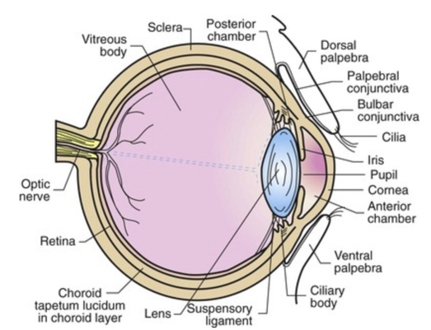
Tear production and draining | - Lacrimal glands: Responsible for the production of tears  - Lacrimal puncta: Two small openings located at the medial canthus of the eye; responsible for drainage of tears
Chemical bonds | - Covalent bond: Where atoms share e⁻ (e.g. CH₄)  - Ionic bond: Where e⁻ are transferred from one atom to another (e.g. NaCl)  - Ions: Have electrical charge (e.g. Na and Cl)  - Cations: Have positive electrical charge (e.g. Na)  - Anions: Have negative electrical charge (e.g. Cl)  - Hydrogen bond: Not a true bond but an electrostatic attraction because e⁻ aren’t shared or transferred, so weaker (e.g. H₂O)
Stimulus for respiration | - CO2—as CO2 level in the blood rises, the pH of the blood goes down, causing blood to become more acidic, which triggers the respiratory center to increase the rate and depth of respiration so that more CO2 can be eliminated  - CO2 levels may increase due to hypoventilation or dyspnea (difficult/labored breathing)  - Hyperventilation may be due to a disease that contributes to problems associated w CO2 levels
Respiratory sounds | - Stridor: A severe, struggling, high-pitched gasping for air due to an obstructed airway; high-pitched inspiratory sound generated from turbulent airflow in the extrathoracic airways  - Ronchi: Wet, mucus-laden wheezing or snoring sounds  - Rales: Crackling or bubbling sound  - Crackle (course or fine): High-pitched, discontinuous inspiratory sound associated w the reopening of airways that closed during expiration  - Stertor: Noise generated from the nasal passages  - Wheeze: High-pitched, continuous inspiratory or expiratory sound associated with narrowing of the airways
Gestation periods | - Dogs: 59-68 days  - Cats: 59-69 days  - Horses: 321-346 days  - Cattle: 271-291 days  - Goats: 146-155 days  - Sheep: 143-151 days  - Pigs: 110-116 days  - Ferrets: 42 days  - Rabbits: 30-32 days  - Hamsters: 19-20 days
Colostrum | - Antibody- (immunoglobin) rich milk produced by the mother right before and after the birth; transfers passive immunity  - Contains more proteins, lipids, amino acids, and essential vitamins than milk  - Laxative effect helps remove meconium from newborn’s intestinal tract  - Immunoglobulin G and A molecules are large, colostrum must be received before gut closure (closing of absorptive pores)—occurs w/in16 hours in kittens and 24 hours in puppies
Afferent vs. Efferent nerves | - Afferent nerves: Sensory nerves; they carry sensations from the skin and other locations toward the CNS  - Efferent nerves: Motor nerves; conduct impulses away from the CNS and send impulses to skeletal muscles, causing muscle contraction and movement
Types of placentation | - Diffuse: Placental attachment sites are diffused over the whole surface of placenta and lining of uterus; loose attachment so easy to detach and pass after delivery (pigs, horses, camelids)  - Cotyledonary: Small, discrete, numerous areas of attachment sites known as placentome; hard to detach, may cause metritis (ruminants)  - Zonary: Placenta attaches to uterus in a belt-shaped zone that encircles the placenta; detaches easily (cats, dogs)  - Discoid: Single, discrete attachment site that is disc-shaped (primates, rabbits, rodents)
Mastication | - Chewing  - Starting point of digestion  - Salivary amylase is the first digestive enzyme; primarily breaks down carbohydrates
Monogastric digestion | - Relatively small glandular stomach where the ingesta is physically mixed by the walls w hydrochloric acid (pH 1.5 to 3.5) and pepsin, which is an enzyme that breaks down protein
Ruminant stomach  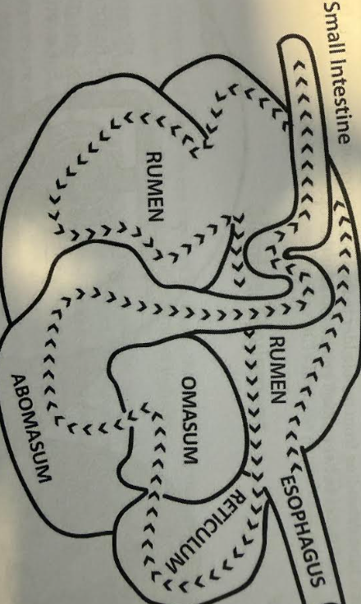 | - Ruminants have a true stomach (abomasum) and have three forestomachs (rumen, reticulum, and omasum)  - Rumen (aka paunch) is where fermentation occurs due to microorganisms that assist in breaking down carbohydrates; occupies most of the left side, from diaphragm to pelvis when expanded (can reach 100 L in adult cow)  - Reticulum (aka honeycomb due to mucosa) lies against the diaphragm; contents can enter and exit rumen easily so reticulum is essentially one unit w rumen (reticulorumen); acts as a garbage-cage for nonfood items and absorbs volatile fatty acids produced in the rumen as carbohydrates are digested by microbes  - Omasum connects reticulorumen to abomasum; absorbs water, magnesium, bicarbonate, and further grinds feed  - Abomasum: Glandular stomach that is responsible for acid and enzymatic digestion
Chyme | - Ingesta after gastric juices act upon it  - Softened, semi-solid mass w water, hydrochloric acid, and digestive enzymes  - Passed from the stomach to the duodenum, where it blends w pancreatic enzymes trypsin and pancreatic lipase  - It then travels to the jejunum and ileum, and then to the large intestine where excess water is absorbed
Reticular/esophageal groove | - Links esophagus with the omasum  - Folds in, turning into a tube-like structure that allows milk to travel directly into the omasum and abomasum (bypassing reticulum and rumen) in the young  - Without it, bacteria in the reticulorumen could ferment milk
Nucleotides | - Molecular building blocks of nucleic acids; composed of a nitrogenous base (named after it), a five-carbon (pentose) sugar, and a phosphate group  - Adenine (A), guanine (G), cytosine (C), uracil (U), and thymine (T)  - A, G, C occur in both RNA and DNA  - U occurs only in RNA  - T occurs only in DNA  - A group of three nucleotides is the code for a specific amino acid (e.g. C-G-T is alanine)  - A gene is a sequence of nucleotides that carries the information to make one peptide chain; long chains of genes are combined w protein to make up chromosomes
Pituitary gland | - Aka hypophysis or master endocrine gland because many hormones produced here direct activity of other endocrine glands  - Connected to the hypothalamus and housed inside the pituitary fossa in the sphenoid bone of the skull  - Actually two glands w different embryologic origins and functions  - Anterior pituitary (adenohypophysis): Rostral/front portion; looks like glandular tissue; produces 7 hormones  - Posterior pituitary (neurohypophysis): Caudal/rear portion; looks like nervous tissue; doesn’t produce hormones but stores/releases 2 produced in the hypothalamus (antidiuretic hormone & oxytocin)
Diastema | - Space between the incisors and the cheek teeth (premolars) in rabbits, between the canine teeth and the first premolar of a horse
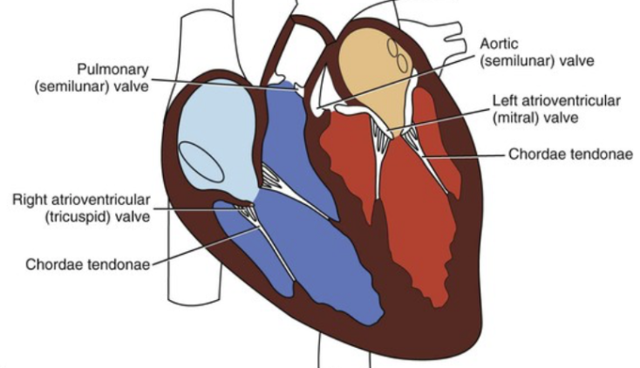 | - Interventricular septum: Stout wall separating the left and right ventricles; continuation of the atrioventricular septum  - Interventricular groove (sulcus): The area of the interventricular septum visible on the outside of the heart; contains coronary blood vessels, filled w fat  - Interatrial septum: Continuation of the myocardium that separates the right and left atria  - Auricles: The flaps that lie on top of the heart on the outside of the atria (part of the atria)  - AV valves: Located bw atria and ventricles; 3 cusps on the right (tricuspid valve), 2 cusps on the left (bicuspid valve)  - Semilunar valves: Control blood flow out of the ventricles into arteries; right is pulmonary valve, left is aortic valve
Myocardium | - Middle and thickest layer of the heart wall; made up of cardiac muscle (epicardium/visceral is the outer layer, endocardium is the inner membrane  - Ventricle walls (myocardium) are thicker than atrial walls because atria only needs to contract enough to push blood into ventricles but ventricles need to send it everywhere
Skeleton | - Axial skeleton (bones of the head and trunk)  - Appendicular skeleton (bones of the limbs)  - Visceral skeleton  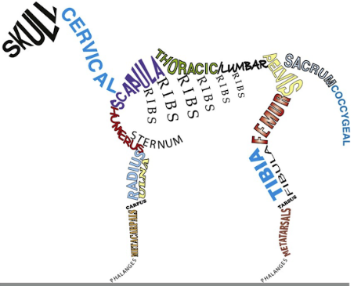
Appendicular skeleton | - Thoracic limb: Scapula, humerus, radius, ulna, carpus, metacarpus, phalanges  - Pelvic limb: Pelvis (ilium, ischium, pubis), femur, tibia, fibula, tarsus, metatarsus, phalanges
Visceral skeleton | - Consists of bones that form in soft organs (viscera) found only in some animals  - Os cordis: Bone in the heart of cattle and sheep; helps support valves  - Os penis: Bone in the penis of dogs, cats, beavers, raccoons, walruses; partially surrounds the penile portion of urethra  - Os rostri: Bone in the nose of swine; strengthens the snout for rooting behavior
Ureters | - Urinary ducts that transport urine away from the kidneys and into the bladder  - Smooth muscle
Functions of the kidney | - Produce urine and help maintain homeostasis by manipulating the composition of blood plasma through the following processes:  - Blood filtration, reabsorption, and secretion  - Fluid balance regulation (amount of urine produced is determined by antidiuretic hormone (ADH) and aldosterone, production of which is influenced by kidneys)  - Acid-base regulation (maintains blood pH by removing acidic hydrogen or basic bicarbonate as needed)  - Hormone production  - Blood pressure regulation (kidneys monitor BP by internal receptors and secrete the hormone renin which starts a cascade of reactions that result in vasoconstriction and retention of sodium and water, increasing BP)
Urine production | - Three phases:  - Filtration: Pressure from the renal artery forces water, salt, and other molecules out of the glomerulus (a cluster of capillaries); this glomerular filtrate is then filtered thru the Bowman’s capsule where waste products, inorganic salts, and excess water are removed  - Reabsorption: Nutrients left over from filtration are reabsorbed into the body thru renal tubules in the proximal convoluted tubules  Concentrating and absorbing of salts happen in loop of Henle  - Secretion: Some substances are released into the distal convoluted ducts from the peritubular capillaries, thereby regulating blood pH during secretion
Symptoms of urinary tract dysfunction | - Anuria: Failure of kidneys to produce urine (<0.5 mL/kg/h)  - Azotemia: Elevated creatinine and BUN; seen w urinary tract obstruction  - Bacteriuria  - Dysuria: Discomfort, pain, burning on urination; seen w bacterial infection  - Glucosuria  - Hematuria: Blood in urine  - Oliguria: Production of only small amount of urine (0.5 to 1 mL/kg/h)  - Polydipsia  - Polyuria (>2 mL/kg/h)  - Pollakiuria: Frequent urination  - Proteinuria (Excessive amounts of protein enter the glomerular filtrate and are not reabsorbed, resulting in protein in the urine)  - PU/PD  - Pyuria: Presence of WBCs in urine  - Stranguria: Straining to urinate  - Uremia: High levels of waste products in urine  - V/D: Vomiting and diarrhea
Pharynx  Larynx | - Pharynx: Throat; part of both GI and respiratory tracts  - Larynx: Voice box; connects pharynx with trachea, supported in place by the hyoid bone
C1-C2 | - C1 is the first cervical vertebra, aka Atlas  - Forms the atlantooccipital joint with the occipital bone (a hinge joint; e.g. nodding)  - Forms the atlantoaxial joint with Axis (pivot joint)  - C2 is the second cervical vertebra, aka Axis
Aortic hiatus | - An opening in the diaphragm that allows the passage of the aorta, thoracic duct, and azygous vein from the thorax to the abdominal cavity  - Thoracic duct is formed by the joining of lymph vessels; empties lymph into the vena cava just before it enters the heart
CNS | - Brain and spinal cord  - Also includes gray matter (neurons) and white matter (myelinated nerve fibers)  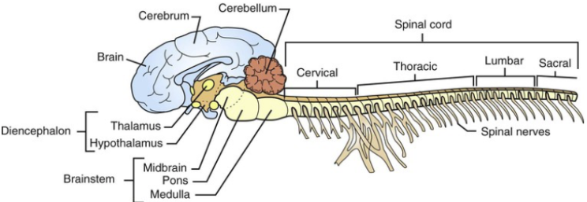
Glial cells (neuroglia) | - Network of tissues and fibers that provide support, protection, and nutrition to neurons  - Found in the brain and the spinal cord
Meninges | - Three layers of dense, fibrous connective tissue membranes that enclose the brain and the spinal cord to protect the CNS  - Dura mater  - Arachnoid matter  - Pia matter
Cerebrospinal fluid | - The clear, water-like fluid that is in and around the brain and the spinal cord  - Works as a cushion to the CNS when jostled  - Source of nourishment for the brain; contains protein, glucose, and ions
Brain | - Divided into four main sections:  - Cerebrum: Made up of gray matter in the cerebral cortex and white matter beneath, divided into lobes; associated w higher order behaviors, receives and interprets sensory info, initiates voluntary nerve impulses, responsible for conscious activity  - Cerebellum: Made up similarly; allows coordinated movement, balance, complex reflexes  - Diencephalon: Not as well defined physically, more a passageway bw cerebellum and brainstem (aka between brain)  Thalamus: Relay station for regulating sensory inputs to cerebrum  Hypothalamus: Interface bw nervous and endocrine systems; temp regulation, hunger, thirst  Pituitary: Endocrine master gland; regulates production and release of hormones  - Brainstem: Connects brain to spinal cord; most primitive part; composed of medulla oblongata, pons, midbrain; subconscious operation and autonomic functions
Foramen magnum | - Where the spinal cord exits the skull; located on the occipital bone and with occipital condyles on either side  - Occipital condyles are the articular surfaces that join the first cervical vertebrae (atlas)
Acetylcholine | - Can be an excitatory or inhibitory NT depending on location  - Excitatory effect that stimulates muscle fibers to contract if at the junction between somatic motor neurons and the muscles they supply  - Inhibitory effect that slows the heart rate if at the site where parasympathetic nerves synapse with the heart
Oxytocin | - Hormone released from the pituitary gland  - Causes the smooth muscle of the estrogen-primed female reproductive tract to contract, aiding the spermatozoa to move further into the oviducts
Nephron | - Basic functional microscopic unit of the kidney (700K/kidney in dogs, 200K in cats, 4m in cattle)  - Each nephron is composed of a renal corpuscle, a proximal convoluted tubule, a loop of Henle, and a distal convoluted tubule  - Renal corpuscle is located in the outer cortex and made up of the glomerulus (capillaries) and Bowman’s capsule surrounding it; PCTs and DCTs are also in outer cortex  - Medulla contains loop of Henle and most of the collecting tubules  - Filtration: Occurs in corpuscle; blood enters glomerulus by the afferent arteriole → pressure causes water, salt, and small molecules to move out of the glomerulus and into the Bowman’s capsule (rate at which this occurs (how fast plasma is filtered) is glomerular filtration rate)  - Reabsorption: Occurs in loop of Henle and PCTs; substances needed by the body are reabsorbed from the glomerular filtrate into the peritubular capillaries  - Secretion: Substances are secreted from the peritubular capillaries into DCT
Circulation pressure | - Blood going through systemic circulation is under higher pressure than blood in the pulmonary circulation  - Blood traveling away from the heart needs higher pressure because of the further distance it travels  - Pulmonary circulation is a short distance and requires a lower pressure
Estrous cycle intervals | - Polyestrous: Cycle continuously throughout the year with a new cycle starting immediately after another ends unless the animal is pregnant (e.g. cattle, swine)  - Seasonally polyestrous: Cycle is continuous through specific times of the year (e.g. horses, sheep, cats)  - Diestrous: Two cycles per year (e.g. dogs)  - Monoestrous: One cycle a year (e.g. foxes, mink)
Gizzard | - One of the two components of a bird’s stomach—proventriculus is the glandular stomach and ventriculus/gizzard is the muscular stomach  - Chemical digestion begins in the proventriculus; gizzard is where food (bones, scales, nuts) is ground  - Gizzard is thin in carnivores and very thick in grain-eaters like turkeys
Crop | - Dilated portion of the esophagus in some birds that act as a pouch for food storage  - Almost no digestion takes place in the crop
Capillary refill time | - 1-2 seconds normally  - Prolonged in animals with compromised cardiac output, low blood pressure, and peripheral vasoconstriction  - Shorter if animal has high blood pressure (e.g. resulting from compensation for anemia as in the case of an animal that lost RBCs to a moderate hookworm infection)
Corpus luteum | - Luteinizing hormone stimulates the ripe follicles in the ovary to rupture and release their ova; the remaining tissue becomes luteinized to form the corpus luteum  - Corpus luteum produces progestin hormones, principally progesterone which is necessary for maintenance of pregnancy if it occurs
Foramen ovale | - Opening in the septum between the right and left atria and ventricles  - Closes shortly after birth
Cardiac conduction system | - Cardiac cycle: One cycle of atrial and ventricular contraction and relaxation; produces one heartbeat  - Structures of the primary cardiac conduction system are:  - SA node: Impulse comes from the sinoatrial node in the right atrium; called pacemaker  - AV node: Next stop; causes contraction w minor delay so that atria can contract before ventricles so ventricles can fill; located in the atrioventricular septum  - Bundle of His: Fibers of boH travel down the septum to the apex, delivering impulse  - Purkinje fiber system: Carries impulse up into left and right ventricular myocardium; located in the septum (wall)  - Impulse from SA node leads to depolarization, which causes the myocardium to contract (repolarization causes it to relax)
Electrocardiogram  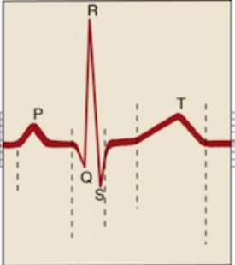 | - P wave: Time it takes the wave of depolarization (contractions) to travel from SA node to the atria; corresponds to the mechanical activity of atrial contractions  - QRS complex: Time of ventricular depolarization (contraction); corresponds to the mechanical activity of ventricular contraction; composed of 3 waves:  - Q wave corresponds to depolarization of the interventricular septum  - R wave corresponds to depolarization of the main mass of ventricles (so it’s the largest)  - S wave corresponds to final part of depolarization of the ventricles at the base of the heart  - T wave: Time of ventricular repolarization (relaxation); corresponds to the time taken by ventricles to get ready for the next contraction by filling with blood from the atria
ECG lead placement | - Smoke over fire, snow over grass + white on right  - Smoke is the black lead, fire is the red lead  Black lead goes on the left arm, red lead on the left leg  - Snow is the white lead, grass is the green lead  - White lead goes on the right arm, green lead on the right leg
Atrioventricular (AV) block | - Happens when the atrial depolarization is not relayed to the ventricles, or when there is a prolonged delay between atrial depolarization and ventricular depolarization  - 3 degrees of AV block:  - 1st degree is characterized by a lengthened PR interval arising from dysfunction of the AV node  - 2nd degree is where one or more (but not all) atrial impulses fail to reach the ventricles—may cause fainting and dizziness; may be present in unfit horses  - 3rd degree (complete heart block) is where no atrial impulses are relayed to the ventricles, leading to ventricles generating rhythm from alternate sites—leads to P and QRS looking to function independently on ECG
Waste-product removal | - Urinary system is the most important route of waste-product removal—it removes nearly all the soluble waste products from blood and transports them out of the body, and it is the major route of elimination of excess water  - Digestive system removes waste products through stools but it is not the most important removal system  - Respiratory system removes carbon dioxide, but is not considered a waste-product removal system
RNA | - Consists of one strand of the nucleotides A-G-C-U  - Three types:  - Transfer RNA copies information in the DNA molecule  - Messenger RNA carries the information out of the nucleus  - Ribosomal RNA uses the information to create the proteins needed by the body
Gavage | - Tube feeding through a stomach tube
Classification of tumors | - Carcinomas: Epithelial tissue tumors (skin, mucous membrane, glandular structures); usually appear as discrete masses and spread primarily through lymphatic vessels, although they can also spread through blood vessels  - Sarcomas: Arise from mesenchymal tissue such as bone, cartilage, and other connective tissues; spread mostly through the bloodstream  - Benign vs. malignant  - Suffix -oma is used for benign tumors (lipoma vs. liposarcoma), except in the case of lymphoma (always malignant) and melanoma (can be either)
Common tumor types | - Lymphoma: Cancer of the immune system cells; common presentation is enlarged lymph nodes in middle aged dogs, and subacute to chronic weight loss 12-14 yo cats  - Mast cell tumor: Most common malignant skin tumor of dogs; commonly on the face in cats  - Osteosarcoma: Occurs most commonly in middle-aged large dogs and primarily affects bones of the appendicular skeleton, usually presenting w lameness  - Oral tumors: Most common oral tumor is melanoma in dogs and squamous Cell Carcinoma (SCC) in cats, usually under the tongue  - Hemangiosarcoma: Occurs most commonly in middle/old-aged large dogs, mostly in the heart, liver, and spleen, causing acute collapse and abdominal swelling (ER cases)
Dysphagia  Aphagia  Polyphagia | - Dysphagia: Difficulty in eating or swallowing  - Aphagia: Inability to swallow  - Polyphagia: Excessive appetite or overeating
Allodynia  Hyperalgesia  Hemialgia | - Allodynia: Painful response to a normally nonpainful stimulus  - Hyperalgesia: Increased sensitivity to a painful stimulus resulting in an amplified pain response  - Hemialgia: Pain that is affecting only half of the body
Fecund | - Capability of producing offspring
-centesis | - A surgical puncture of a body cavity or organ with a hollow needle, most often to remove fluid (e.g. pericardiocentesis—removal of fluid via a needle inserted into the pericardial sac)
-plasia | - Growth or formation; used to describe cellular multiplication and development (e.g. hyperplasia is an increase in the number of cells, amyoplasia is lack of muscle formation or development)
-sarc | - Flesh
-lapar | - Flank
Suffixes used in names of blood disorders | - -philia: Increase in blood levels of that type of cell (Neutrophilia)  - -osis: Abnormal increase in blood levels of that type of cell; can also refer to a disease process (Lymphocytosis)  - -penia: Decrease in blood levels of that type of cell (Neutropenia)  - -lysis: Destruction of that type of cell (Hemolysis)  - -emia: Presence of a substance in the blood (Polycythemia)  - -stasis: To stop or stabilize (Hemostasis)
-ptosis | - Downward movement, prolapse (e.g. nephroptosis—downward displacement or prolapse of the kidney)
Excoriation | - Erosion or ulceration caused by scratching, biting or rubbing  - Erosion: Shallow epidermal defect that does not penetrate basal laminar zone  - Ulcer: break in continuity of epidermis w exposure of underlying dermis
Micturition | - Voiding, urination
Palpebration | - An abnormal contraction of the eyelid
Azotemia | - Buildup of nitrogenous waste material in the blood caused by kidney failure  - Most important two are urea and creatinine, both byproducts of protein metabolism
Albumin | - A plasma protein manufactured by the liver  - Maintains the osmotic fluid balance between capillaries and tissues; plays a vital role in keeping fluids in the vascular system  - Doesn’t easily pass through most capillary walls due to large size, meaning it exerts osmotic pressure and prevents water from moving out of the capillaries into the extravascular space  - Losing this balance will lead to abnormal fluid accumulations  - Hypoalbuminemia may result due to loss of protein through kidneys or GI tract (e.g. gastroenteritis); seen in liver failure but not in chronic liver disease
Ecchymosis  Petechiae | - Petechiae: Small, pinpoint red/purple spots that appear on the skin or mucous membranes due to tiny broken blood vessels  - Ecchymosis: Blood leaking from a ruptured vessel into SQ tissue; larger than petechiae
Hypercapnia  Hypoxemia  Hypoxia | - Hypercapnia: Increased amount of carbon dioxide in the blood  - Hypoxemia: Low blood-oxygen levels  - Hypoxia: Low tissue-oxygen levels
Refeeding syndrome | - A condition that may occur following the reintroduction of nutrition after prolonged starvation  - When nutrition is reintroduced via oral, enteral or parenteral feeding, animals can exhibit fluid and electrolyte shifts  - Hypokalemia is the most commonly detected electrolyte disturbance when providing nutritional support to a patient suffering from refeeding syndrome; glucose is absorbed, insulin is secreted, and cells along with glucose take up potassium  - Hypomagnesemia is more commonly seen in starvation patients
Elimination of oral medications | - Orally administered drugs travel through the GI tract and most are absorbed in the small intestine  - After absorption across the intestinal wall, they enter the hepatic portal circulation and are routed directly to the liver  - Liver removes potentially toxic substances before they reach the systemic blood circulation, meaning drugs may be partially or completely broken down because of this mechanism (first-pass effect)  - Small intestine is after the stomach, so drugs do not enter the stomach  - Some drugs may be eliminated in the urine or feces, but liver is more common
Taurine | - An essential amino acid that cats cannot synthesize, so it must be included in their diet  - Healthy dogs are able to synthesize taurine from other amino acids  - Another reason (in addition to cats being carnivores and dogs omnivores) cats shouldn’t be fed dog food—may lead to taurine deficiency, which can cause retinal degeneration resulting in blindness, DCM, etc.
Coupage | - The act of striking the chest wall rhythmically w cupped hands (starting caudally and working forward), creating an air cushion impact so that tenacious muscle is dislodged, phlegm congestion is loosened, and coughing is encouraged  - Used in pulmonary disease, to help loosen purulent material within the pulmonary parenchyma (i.e. functional tissue of lungs like alveoli)  - Contraindicated in fractured ribs or other thoracic traumas  - Considered “tapotement” i.e. tapping motion to stimulate nerve endings
Hemoptysis | - Coughing up blood
Mannitol | - An osmotic diuretic that decreases intracranial pressure by reducing blood viscosity  - Allows an increase in blood flow (thus an increase in oxygen delivery) to the brain, and causes a decrease in the water content of the brain
Integument | - One of the largest organs; composed of all four tissue types, and includes skin, horns, hooves, claws, glands, hair  - Skin forms two distinct layers—epidermis is the outer layer, dermis (corium) is the inner layer  - Epidermis is composed of keratinized stratified squamous epithelium; avascular; protects from infection  - Dermis is made of dense fibroelastic connective tissue and contains blood vessels (vascular) and sensory nerves; gives skin strength and support  - Hypodermis (SC layer) is below; composed of adipose tissue and acts as a thermoinsulator and mechanical shock absorber
Cardiac output | - Volume of blood that is ejected out of the left ventricle over a minute; must be sufficient to supply oxygen and nutrients to the whole body  - Determined by two factors—stroke volume and heart rate  CO = SV x HR  - Stroke volume: Volume of blood ejected from the left ventricle during one contraction or systole (aka systolic discharge); represent strength of the heartbeat, which is determined by two factors itself—preload and afterload  - Preload: Volume of blood ventricle receives from the atrium (80% occurs passively, 20% requires contraction, which happens during atrial systole)  - Afterload: Physical resistance presented by the artery that the ventricle is ejecting into, affected by e.g. partial blockage, which will decrease amount ejected  - Heart rate: Number of ventricular contractions in 1 min
Erythrocytes | - Mature RBCs; contain hemoglobin, which carries oxygen to the cells and carbon dioxide from cells to lung  - No nucleus, mitochondria (utilize glucose from plasma for energy instead), ribosomes; center is thinner so appears lighter when stained  - RBCs maintain cell shape (concave disk) and are deformable, which allows changing shape to travel through various vessels  - Senescence is the process of aging—ave. lifespan of RBCs is 120 days in dogs, 68 days in cats, 150 days in horse and sheep, 160 days in cows, 20-30 days in mice  - Hypochromic: A condition where RBCs have less hemoglobin, making them appear pale or less colored (e.g. due to iron deficiency)
Leukocytes | - WBCs; generally larger than RBCs  - Classified as granulocytes and agranulocytes  - Mature granulocytes contain prominent cytoplasmic granules; include neutrophils, eosinophils, basophils  - Neutrophils: Phagocytosis; found in tissues  - Eosinophils: Allergic reactions, anaphylaxis, and phagocytosis; found in tissues; stain red  - Basophils: Initiation of immune and allergic reactions; found in tissues, stain blue  - Monocytes: Phagocytosis, process antigens (macrophage); found in tissues or blood  - B cells (lymphocyte): Antibody production, humoral immunity; found in lymphoid tissue  - T cells (lymphocyte): Cytokine production, cell-mediated immunity; found in lymphoid and other tissues
Humors of the eye | - Make up the interior of the eyeball  - Aqueous compartment is in front of the lens and ciliary body and contains the clear, watery fluid aqueous humor  - Vitreous compartment in behind the lens and ciliary body and contains the clear, soft gelatin-like fluid vitreous humor  - Basic mechanism of glaucoma is production of aqueous fluid faster than it is drained, usually due to insufficient drainage (as opposed to overproduction) which leads to intraocular pressure in the anterior chamber of the eye
Ocular pressure | - Normal ocular pressure in cats and dogs is 15 – 25 mmHg  - Ocular pressure below 10 mmHg indicates uveitis  - Ocular pressure above 25 mmHg indicates glaucoma  - At 80 mmHg, emergency intervention would be necessary—pain management, risk of vision loss, eye rupture
Monocular vs. Binocular vision | - Depends on the location of the eyes  - Monocular vision field: Lateral visual field of each eye; no input from the other eye  - Herbivores have lateral orbits, meaning small frontal binocular field and two large lateral fields; helps to see predators  - Horses and cattle have 280° monocular vision; only have blind areas right in front of the nose and directly behind  - Binocular vision field: Frontal part of the visual field covered by both eyes; required for depth perception  - Species with front-facing eyes have a large binocular visual field  - Depth is important for predator species, larger blind spot is less of a concern (dogs, cats, raptors)
- Stallion: Intact adult male horse  - Colt: Intact male horse younger than 3  - Yearling: Horse around the age of 1  - Gelding: Castrated male horse  - Mare: Adult female horse older than 3  - Filly: Juvenile female horse (<3 or before birth)  - Foal: Juvenile horse (before weaning)  - Bull: Intact adult male cattle  - Steer: Castrated male cattle  - Cow: Adult female cattle older than 3  - Heifer: Juvenile female cattle (<3 or before birth)  - Calf: Juvenile cattle (before weaning) | - Buck/Billy: Intact adult male goat  - Doe/Nanny: Adult female goat  - Wether: Castrated male goat  - Kid: Juvenile goat (before weaning)  - Ram: Intact adult male sheep  - Ewe: Adult female sheep older than 1  - Wether: Castrated male sheep  - Lamb: Juvenile sheep (before weaning)  - Female guinea pig: Sow  - Male guinea pig: Boar
- Boar: Intact adult male pig  - Barrow: Castrated male pig  - Sow: Adult female pig  - Gilt: Juvenile female pig (<3 or before birth)  - Piglet: Juvenile pig (before weaning)  - Jack: Male donkey  - Jenny: Female donkey  - Mule: Offspring of horse and donkey | - Drake: Adult male duck  - Gander: Adult male goose  - Tom: Adult male turkey  - Hen: Adult female chicken or turkey  - Poult: Young turkey  - Broilers/Fryers: Chicken younger than 10 weeks (tender)  - Roasters: Chicken 10-12 weeks (less tender meat)  - Layers: Chicken used for egg production  - Doe: Female rabbit  - Buck: Female rabbit  - Kit: Young rabbit
Nutrients | - Divided into six categories: water, carbohydrates, lipids, proteins, vitamins, and minerals  - Energy-producing nutrients are protein, carbohydrates, and fats  - Water, minerals, and vitamins are non-energy-producing nutrients
Carbohydrate | - Molecules used for energy, storage of energy, and cellular structures  - Made up of carbon, hydrogen, oxygen  - Used in the form of glucose, stored as glycogen in muscle, liver, or as body fat  - Include sugar, starch, cellulose  - Can be soluble or insoluble; solubles like mono- and disaccharides (e.g. glucose) are digestible, insolubles like starch and fiber aren’t  - Insoluble carbohydrates (primarily polysaccharides) aid in regulating blood glucose levels  - Used for diabetes, to manage constipation and diarrhea, and found in pet food to increase bulk and promote satiety
Protein | - Most abundant organic molecule in the body  - Made up of 20-21 amino acids; some are essential—must be present in the food (taurine and arginine for cats), others are nonessential since the body can manufacture itself (dogs can synthesize 11 amino acids, dogs 10)  - Tyrosine, alanine, asparagine, and aspartate are nonessential amino acid  - Histidine, isoleucine, arginine, and methionine are essential amino acids  - Used for energy only after the necessary amount is used for building body tissues and facilitating some hormonal processes and body functions
Lipids | - Most concentrated source of energy, enhances palatability and caloric density  - Required by fat-soluble vitamins (A-D-E-K) for absorption, transportation, and storage  - Essential fatty acids (EFAs) are necessary to maintain skin and coat, and synthesis of cell membranes, sex hormones, prostaglandins, also important in temp regulation, immune system function  - EFAs can be saturated (carbon chains w no double bond) or unsaturated (one or more double bonds)  - Linoelic acid and arachidonic acid are EFAs required for normal metabolism
Minerals | - Less than 1% but essential for metabolic processes  - Macrominerals: Calcium, phosphorus, potassium, sodium, magnesium; aid in electrolyte and water balance, skeletal integrity, muscle and nerve conduction, cellular function; expressed in %  - Microminerals (trace minerals): Iron, zinc, copper, manganese, iodine, cobalt, selenium; expressed in parts per million (ppm)  - “Ash” is used to refer to all minerals in a food product—high ash content in some cat foods has been linked to urinary tract disease
Vitamins | - Function as enzymes, coenzymes, and enzyme precursors  - Can be water-soluble or fat-soluble—B complex and C are water-soluble and not stored in the body, A-D-E-K are fat-soluble and stored in fat or liver, so excess may be toxic  - Levels of vitamin E and other antioxidant nutrients (Vitamins A, C, and beta carotene) given to pets should be appropriate to the levels of polyunsaturated fatty acids, trace minerals, and oxidants in the food  - Vitamin C is the only vitamin that can be synthesized from glucose by dogs and cats  - Dogs and cats must receive vitamins A, B6, and K in their diets, cats require niacin (B3) as well  - Vit D deficiency rickets (weak bones); Vit A or E deficiency causes reproductive failure; vit K deficiency causes increased clotting time
Hormones of the pituitary gland-anterior lobe  - Corticotropin (adrenocorticotropic hormone): Stimulates production and secretion of hormones by the adrenal cortex  - Growth hormone (somatotropin): Promotes growth, influences the metabolism of proteins, carbohydrates, and lipids  - Follicle-stimulating hormone: Stimulates growth of follicles in the ovaries, induces formation of sperm in the testes  - Luteinizing hormone: Stimulates ovulation and development of the corpus luteum, as well as production of testosterone by the testes  - Prolactin: Stimulates the mammary glands to produce and secrete milk  - Thyroid-stimulating hormone: Stimulates the production and secretion of thyroid hormones by the thyroid gland | Hormones of the pituitary gland-posterior lobe  - Antidiuretic hormone (arginine vasopressin): Causes kidneys to conserve water by concentrating the urine and reducing urine volume; lesser role in regulating blood pressure  - Oxytocin: Stimulates contraction of smooth muscle of the uterus during labor, facilitates ejection of milk from the breast during nursing
Hormones of the parathyroid glands  - Parathyroid hormone: Raises blood calcium concentration by promoting absorption of calcium by the intestine, mobilizing calcium salts from bones, and increasing the ability of the kidney to recover calcium from urine; also lowers phosphate by enhancing its excretion by the kidneys  Hormones of the thyroid glands  - Thyroid hormones (T3, T4): Increase basal metabolic rate; synthesize proteins; regulate protein, fat, and carbohydrate metabolism (control all metabolic processes); produced by the follicular cells and stored in the gland until needed  - Calcitonin: Participates in calcium and phosphorus metabolism; reduces calcium levels in the blood | Hormones of the adrenal glands  - Aldosterone: Helps regulate salt and water balance by retaining sodium (salt) and water and excreting potassium  - Cortisol: Widespread effects; involved in stress response; active in carbohydrate, fat, and protein metabolism; helps maintain blood sugar level; suppresses inflammation and immune responses; can interfere with healing of wounds and decrease scar formation  - Epinephrine (adrenaline) and norepinephrine: Released in response to stress; stimulates heart action and increases cardiac output, blood pressure, metabolic rate, and blood glucose concentration; raises blood sugar and fatty acid levels
Hormones of the pancreas  - Insulin: Lowers blood sugar level; affects metabolism of sugar, protein, and fat  - Glucagon: Raises blood sugar level, opposing the action of insulin  Hormones of the ovaries  - Estrogen: Controls female reproductive system along with other hormones; involved in maturation of reproductive organs at puberty  - Progesterone: Prepares the uterus for implantation of the fertilized egg, maintains pregnancy, and promotes development of the mammary glands | Hormones of the testes  - Testosterone: Responsible for development of male reproductive system and secondary male sexual characteristics
Reproduction  Insemination | - Copulation: Natural act of reproduction  - Artificial insemination: Injection of semen into the vagina or uterus by the use of a syringe  - In vivo fertilization: Fertilization occurs naturally within the body; includes injection of the sperm and ovum into the uterus  - In vitro fertilization: Injection of an embryo into the uterus
Semen collection | - First (pre-sperm) fraction comes out before ejaculation of sperm; contains a thing fluid that cleanses the urethra  - Second fraction is sperm-rich and milky; contains spermatozoa  - Third (gel) fraction helps flush out remaining sperm in the urethra; gelatinous
Intestines | Small intestine: Major site of digestion and absorption; produces digestive enzymes; divided into 3 regions: duodenum, jejunum, ileum  - Duodenum is the shortest segment; gallbladder and pancreas attach to it (digestive enzymes produced by the pancreas and liver pass through the pancreas to mix w food in the duodenum)  - Jejunum is the longest portion, where most nutrient absorption occurs through the villi (tiny fingerlike projections)  - Ileum is also short, leads to the cecum  Large intestine: Absorbs water to maintain hydration and some electrolytes (esp sodium), stores waste for defecation; divided into ascending colon, transverse colon, descending colon  - Begins at the ileocecocolic valve, continues as the cecum, ascending, transverse, and descending colon, rectum, and anus  - Has no villi, circular folds, or secreted enzymes (unlike small intestine); large number of goblet cells secrete mucus  - Absorbs vitamins B-K, propels waste toward rectum
Diarrhea | - Diarrhea and bleeding that originate in the jejunum and ileum present as melena (partially digested blood)  vs. hematochezia, undigested blood on the outside of stool, indicative of disease in the colon or rectum (fresh, bright red blood, indicating blood loss in the lower GI tract)  - Small bowel diarrhea results in normal frequency of bowel movements but increased volume; large bowel diarrhea results in increased frequency, decreased volume, mucus in feces, and tenesmus (straining)  - Involvement of the stomach is most associated w vomiting; causes no change to diarrhea  - Colitis results in frank blood mixed in the diarrhea
Steatorrhea | - Passage of large volumes of pale, fatty feces  - Usually associated w exocrine pancreatic insufficiency, which is caused by insufficient production and secretion of pancreatic digestive enzymes
Vomiting | - GI ulceration results in frank blood if the bleeding from ulceration is fresh, or dark, black flecks resembling coffee grounds if blood digested in the stomach  - Green fluid in the vomitus indicates involvement of fresh bile in the duodenum  - White, frothy vomitus indicates gastric or esophageal disorders
Jaundice/Icterus | - Characterized by the yellowing of mucous membranes, skin, and sclera  - May be caused by liver failure, excessive RBC destruction, or blockage of bile ducts  - Liver disease prevents liver from conjugating normal amounts of bilirubin (conjugation turns bilirubin water-soluble)  - Excess RBC breakdown leads to excess unconjugated bilirubin in plasma (hyperbilirubinemia)—when the liver cannot keep up conjugating, the excess bilirubin is deposited in tissues  - Obstructed bile ducts prevent conjugated bilirubin to pass w bile into the intestines, leading to bilirubin backing up into the bloodstream and then to tissues
Liver disease | - Categorized as drug- or toxin-induced liver disease, infectious liver disease, feline hepatic lipidosis, neoplastic liver disease, and congenital portosystemic shunts (a vascular abnormality in which the hepatic portal vein empties directly into the caudal vena cava, bypassing the liver)  - Signs are vague in early stages—anorexia, V/D or constipation, weight loss, PU/PD, pyrexia, melena, hematuria, plus hypersalivation in cats  - Some may develop bleeding tendencies because of vitamin K malabsorption (requires bile acids for absorption)  - Jaundice may develop as the disease progresses  - Protein malnutrition is seen, manifesting as weight loss, muscle atrophy, and hypoalbuminemia.
Serum colors | - Serum centrifuged in a microhematocrit tube:  - Icterus manifests as yellow-to-orange serum because of increased bilirubin levels in serum  - Hemolyzed serum is red because of increased hemoglobin levels in serum  - Hyperproteinemia results in increased total protein readings and presents as yellow fluid w high viscosity if severe (e.g. feline infectious peritonitis)  - Lipemia manifests as turbid, white serum due to increased triglyceride level
Bilirubin | - Brownish-yellow substance found in bile  - By-product of hemoglobin breakdown; formed by the metabolism of heme, which is the deep red iron-containing pigment  - Responsible for yellowish appearance in bruises, as well as in jaundice
Core vaccines | - Dogs  - Rabies  - Distemper  - Hepatitis (Adenovirus-2)  - Canine parvovirus (CPV)  - Cats  - Rabies  - FVRCP (herpesvirus (feline viral rhinotracheitis) + calicivirus + panleukopenia)  - Horses  - Rabies  - Tetanus  - West Nile virus  - Eastern/Western equine encephalomyelitis
Canine distemper vaccine | - Combination vaccine—protects against distemper, canine adenovirus-2, canine adenovirus-1, parvovirus, and parainfluenza (DA2PP or DA2PPV)  - Distemper virus affects the respiratory system, digestive system, brain, and nervous system; highly contagious and potentially fatal  - Adenovirus-2 causes respiratory disease  - Parvovirus attacks the immune system and digestive system, causes V/D; highly contagious and potentially fatal  - Parainfluenza affects the respiratory system
Borborygmus | - Rumbling noise caused by propulsion of gas and ingesta through the intestines  - 1-3 borborygmi/minute indicates normal motility  - Absence of borborygmus is ileus, or intestinal standstill, indicative of serious intestinal disease
Hydration status | - Skin should be elastic snapping back into place after being tented at the thorax or lumbar region  - Skin turgor is the speed at which skin returns to normal position after being pulled away; prolonged/delayed in dehydrated animals, shortened in overhydrated animals  - Skin left standing after the skin tent test indicated dehydration  - 5-6% dehydration (mild): Slight loss of skin elasticity  - 7-10% dehydration (mild up to 8, moderate 8-10): More loss of skin elasticity, increased CRT, sunken eyes  - 10-12% dehydration (moderate): No return of skin to original position, increased CRT, dry mucous membranes, sunken and dull eyes, tachycardia, rapid and weak pulses  - 12-15% dehydration (severe) can lead to death  - IV (central/peripheral) and IO preferred for severe dehydration; SC won’t enter intravascular space, especially due to lack of intravascular volume and blood flow to the tissues
Dehydration | - <5% dehydration: No signs—BAR w normal mentation, moist MM, CRT < 2 seconds, normal skin turgor of < 1 second  - 5-7% dehydration: QAR, tacky gums, CRT of 2-3 seconds, delayed turgor of 1-2 seconds  - 8-9% dehydration: Weak, lethargic, sternal or fully recumbent, dry MM, CRT and turgor of 3-4 seconds  - 10-12% dehydration: Recumbent, barely conscious, weak and rapid pulses, sunken eyes, CRT of 4-5 seconds, turgor of 5-8 seconds  - 12-15% dehydration: Unconscious, cardiovascular shock, rapid and thready pulse, severely sunken eyes, dry and contracted tongue and MM, CRT of 5-8 seconds, no turgor
Mucous membrane color | - Hyperemic (injected) membranes are a deep brick-red color and appear injected; most commonly seen in hyperthermia, sepsis, and polycythemia (increased PCV, increased RBCs)  - Occurs in hyperthermia due to vasodilation needed for heat loss  - In a septic patient blood pools due to loss of vascular tone; septic shock occurs when there is a circulatory failure secondary to sepsis, and in early shock there is a hyperdynamic response (tachycardia, vasodilation, fever, and bounding pulses) causing red mucous membranes  - Cyanotic membranes are bluish (deep red-purple to pale blue) due to desaturated hemoglobin, but more than 5 g/dL of hemoglobin wouldn’t be carrying oxygen (PCV of 15%) for membranes to turn blue  - Icteric (jaundice) occurs due to buildup of bilirubin in the plasma and tissues (hyperbilirubinemia)  - Pale (pale pink to gray/white) membranes indicate anemia, low PCV or circulatory shutdown;
CRT + MM color combinations | - Pink MM, Normal CRT: Healthy patient  - Yellow MM, Normal CRT: Yellow MM indicates elevated bilirubin (liver disease, hemolytic anemia), in which the CRT is often not affected.  - Pale MM, Prolonged CRT: MM is pale and CRT is prolonged in a patient experiencing hypovolemic shock resulting from vasoconstriction reducing blood flow to the periphery  - Red MM, Rapid CRT: Red MM indicates vasodilation that can occur with systemic inflammation or hyperthermia; in these cases CRT is often rapid
Shock | - Results from altered blood flow or impaired oxygen delivery to tissues  - Early stage signs are depression, anxiety, tachycardia, tachypnea, which later turn into severe tachycardia, altered mental status, hypotension, pale MM, weak pulses, and in the terminal stage massive vasodilation, hypotension, cardiac arrest
Hypovolemic shock | - Results from decreased intravascular fluid volume  - May be due to trauma, hemorrhage, severe V/D  - Signs include delayed CRT, weak pulses, pale MM, altered mentation  - Treated w IV fluids, possibly blood transfusions  - Most common form in dogs and cats
Distributive shock | - Results from maldistribution of blood flow, from inappropriate vasodilation leading to blood pooling  - Seen w anaphylaxis, sepsis, hear stroke, envenomation  - Signs include weak or bounding pulses, pink MM  - Fluid therapy needed; vasopressors used to restore normal vascular tone
Obstructive shock | - Occurs when venous return to the heart is impaired  - Seen w GDV (distended stomach impairs venous return from abdomen), pericardial tamponade (increased intrapericardial pressure collapses right atrium)  - Treated by addressing underlying condition
Cardiogenic shock | - Occurs secondary to heart problems  - Signs include weak pulses, hypotension, pale MM, cold extremities, pulmonary edema, ascites (fluid in abdominal cavity), heart murmur (signs of heart failure)  - Fluids are contraindicated; treated by improving heart function and diuretics to resolve pulmonary edema
Septic shock | - Occurs after severe infections like pneumonia, parvovirus, gastric or intestinal perforation, infected bite wound, or due to tissue damage resulting from heat stroke or pancreatitis  - Inflammatory response to sepsis causes increased vasodilation, so bright red MM and bounding pulses are common, fever common  - Hypotension worsens as shock progresses, pale and weaker impulses take over  - Hypoglycemia occurs because inflammatory mediators, hypotension, and hypovolemia combine to cause a decreased intake, decreased production, and increased use of glucose  - Treated by treating source of infection, w fluid therapy, and broad-spectrum antibiotics
Bacteria vs. Virus | - Bacteria living, single-celled organisms that can reproduce on their own  - Viruses are non-living particles made of genetic material that need a host cell to replicate
Resting energy requirement (RER) | - Formula to calculate RER (kcal/day) in dogs and cats is:  $$70×(\text{body weight in kg})^{0.75}$$  - Acc. to another source, RER is 15 kcal/lb for dogs and 20 kcal/lb for cats  - DER (daily energy requirement) can be calculated based on this by multiplying RER by standard factors related to energy reads (e.g. working dogs)
Vertical transmission of diseases | - Spread of a disease from mother to offspring before or after parturition, either transplacentally or through breastmilk
- Endemic: A disease that is constantly present in a particular geographic area or population group, existing at a predictable or baseline level
- Nosocomial: Originating in a hospital
- Iatrogenic: Disease resulting from the activity of the veterinarian, or from any adverse condition in a patient that results from treatment
Uroliths | - A urolith is a pathologic stone formed from mineral salts found in the urinary tract  - Struvite uroliths (triple phosphate uroliths); found in alkaline urine  - Ammonium urate uroliths (ammonium acid urate uroliths); found in acidic urine  - Calcium oxalate uroliths; found in acidic urine  - Cystine uroliths; found in acidic urine  - Formation is dependent on urine pH, concentration, and saturation (protein in the urine has no effect)
Agencies | - FDA: Food and Drug Administration (Center for Veterinary Medicine (CVM)) regulates food safety, new ingredients, food labels incl. nutritional claims; responsibilities are (1) establishing labeling regulations, (2) specifying permitted ingredients like drugs and additives, (3) enforcing regulations about chemical and microbiologic contamination, (4) describing acceptable manufacturing procedures  - USDA: United States Department of Agriculture regulates pet food labels and research facilities; responsible for ingredients used in pet foods, conducts inspections of farms and manufacturers  - FTC: Federal Trade Commission regulates trade and advertising of pet foods  - AAFCO: Association of American Feed Control Officials is a private org. that sets standards for substantiation claims and nutritional profiles for pet food; has no regulatory authority but agencies often mandate these into law
Pneumothorax | - Air trapped in the chest cavity between the lungs and the chest wall  - Subcutaneous emphysema: Air trapped under the skin  - Lungs collapse because of increased pressure w/in the chest cavity  - A chest tube can help evacuate the air and allow the lungs to expand
Eclampsia | - A condition of hypocalcemia arising from lactation  - Results in muscle spasms, fever, tachycardia, and seizures  - In dogs and cats, cows, many exotics  - Treated by rapidly increasing level of calcium in the blood by IV infusion of a calcium solution
Multi- vs. uniparous  (Poly- vs. monotocous) | - Multiparous/polytocous: Animals that are able to have more than one offspring at a time; have longer uterine horns to carry several offspring  - Uniparous/monotocous: Animals that can carry one offspring at a time; fetuses grow in the uterus
Oviparous | - Oviparous: Species that produce eggs in which the embryo develops outside the body (e.g. birds)  - The term gravid is used in reptiles that carry and lay eggs (oviparous)  - Viviparous: Species that give birth to young that develop w/in the maternal body (e.g. placental mammals, some reptiles, some amphibians)  - Oviviparous: Species where embryos develop inside eggs that remain inside the mother's body until they hatch, resulting in live birth without a placenta (e.g. some snakes)
Wound types | - Open wound: Injury that has an external break in the tissue  - Abrasion: Open wound w a loss of the epidermis plus some of the dermis  - Avulsion: Open wound that is a result of the tissues being torn from their attachments  - Incision: Open wound caused by a sharp tool (surgery)  - Laceration: Open wound caused by tearing, which creates superficial and deeper tissue damage  - Puncture: Open wound created by a sharp object (tooth); high risk of infection and severe tissue damage  - Closed wound: Injury resulting from damage beneath the skin’s surface  - Contusions/blunt force trauma: Close wound that damages (but doesn’t break) the skin and the tissue underneath  - Crushing injuries: Close wounds caused by excess force over a time
Wound healing | - Inflammatory phase: Initial phase following injury; ass. w appearance of scabs (formed from blood, serum, pus) that protect the wound  - Debridement phase: Starts 6 hours after injury; neutrophils and monocytes remove foreign material, bacteria, necrotic tissue  - Repair phase: Starts 3-5 days after, if foreign material has been extracted  - Maturation phase: Can take up to years; complete wound recovery is achieved by refashioning collagen fibers and other fibrous tissue; includes scar lightening  - Multiple phases can operate simultaneously
Wound repair | - First intention healing: Occurs in tissues where wound edges are held in close apposition to one another (e.g. sutured wounds, superficial scratches); little to no granulation tissue is formed, scarring is minimal  - Second intention healing: Occurs in tissues where edges are separated and granulation tissue is needed to close the gap, resulting in scarring; epithelialization, fibrosis, and contraction are part of the healing process
Tissue healing | - Inflammatory phase: Acute vascular response and cellular infiltration  - Proliferative phase: Fibroblasts proliferate to repair damaged tissue; granulation occurs (aka reparative or fibroblastic phase)  - Maturation phase: Collagen fibers form crosslinks to become stable
Keloid | - An overgrowth of scar tissue at the site of injury
Bandaging | - 3 layers of bandaging: Non-adhesive primary layer (over granulated tissue), secondary layer to soak up exudates, tertiary layer (like Vet Wrap) for reinforcement  - 3 types of bandages/dressings for wounds:  - Dry-to-dry: For loose necrotic tissue; dry gauze stays in place w application of dry, absorbent wrap; naturally debrides and removes necrotic tissue w bandage change  - Wet-to-dry: For infected or open wounds; saline-moistened or medicated bandage is placed under dry; treats infection and absorbs exudates; removed when dry  - Wet-to-wet: For chronic or larger, ulcerated wounds that require internal tissue growth before epidermal tissue can grow (e.g. deep pressure sores); removed when still wet
Functions of bandaging in orthopedic injuries | - Stabilizing fractures or joints  - Decreasing swelling  - Preventing weight-bearing  - Restricting range of motion  - Maintaining the splint/cast in position  - Protecting soft tissue from additional injury
Bandages of the limb | - Should be applied from distal to proximal
Medicinal honey | - Applied to bandages for second intention wound healing  - Benefits include creating a hypertonic environment, providing a source of energy for healing cells, aiding in debridement and granulation formation, healing burns, acting like hydrogen peroxide, antibacterial and anti-inflammatory effects, antioxidant properties  - Can be placed on the wound or on the bandage  - Shouldn’t be used once granulation phase starts—it’s acidic (low in pH), so using honey in this phase can lead to overgranulation  - Bandage must be changed every 24 hours
Fluid therapy | - Fluid can be given through oral, SC, percutaneous, IV, or intramedullary routes  - SC can’t be used in shock or severe dehydration because it is too slow, IV preferred  - Intramedullary preferred in very small/young animals  - Lost fluids (urine, vomit, etc.) should be measured to calculate rehydration, maintenance, and replacement (Normal urine output on fluids is 1–2 mL/kg/h)  - Replacement solutions are Normosol R and LRS; maintenance solutions are Normosol M and normal saline w KCl  - Contraindicated for pulmonary edema, pulmonary contusions, brain injury, severe ascites (fluid accumulation in abdomen), cerebral edema, CHF  - Over-hydration symptoms include restlessness, high RR, wheezing or other lung sounds, rise in BP, chemosis (swelling of eye whites), pitting edema (dent when pressed)
Fluids used in fluid therapy | - Crystalloids: Water rich in electrolytes  - Colloids: Large, heavy molecules suspended in isotonic crystalloid
Routes of fluid administration | - SC: Warmed sterile isotonic fluids given SC useful when IV access is difficult, but absorption is very slow so should be avoided in severely dehydrated animals  - IP: Warmed sterile hypotonic or isotonic fluids may be administered (aseptically) into the peritoneal cavity; more efficient than SC due to its absorptive capacity  - IO: Administration of fluids into the medullary cavity of a long bone like the proximal femur or tibia; esp. useful in exotic species, neonates, and trauma patients where venous access compromised; absorption is as rapid as IV  - IV: Sterile warmed fluids are administered into the cephalic or saphenous vein; most rapid and effective way, so good for severely dehydrated patients
Crystalloids | - Good for rehydrating extravascular spaces since crystalloids can cross the vascular wall due to their small size  - Also useful in correcting acid-base imbalances  - Hypotonic (D5W, 0.45% sodium chloride, Normasol M, Plasmalyte 56)  - D5W is oxidized to CO2 and H2O, providing free water; should be used in case of free-water deficit or hypernatremia, not for shock  - Isotonic (Plasmalyte 148, Normasol R, LRS)  - Plasma-Lyte 48 provides rapid intravascular volume expansion
Colloids | - Remain in the blood vessel due to larger size (unable to cross vascular wall), allowing them to improve BP by holding fluid in the intravascular space  - May contain proteins like albumin or synthetic molecules like Hetastarch, making them suitable or patients w low plasma protein levels or in cardiovascular shock  - Hypertonic saline (a hypertonic crystalloid) and Hetastarch (colloid) expand vascular volume; useful in patients that won’t tolerate a large volume of fluids (head trauma, heart failure)
Osmolality | - Concentration of dissolved particles in a fluid  - Normal osmolality of blood is bw 280 – 310 mOsms/L  - Isotonic fluids have the same osmolality as blood  - Hypotonic fluids have osmolality less than 280 mOsms/L  - Hypertonic fluids have osmolality more than 310 mOsms/L  - Peripheral catheters are used for fluids w osmolality of up to 600 mOsms/L; any higher can cause phlebitis
Fluid replacement and maintenance volumes | - Fluid replacement volume:  - Hypovolemic shock or severe dehydration: 60-90 mL/kg/hr over 12 to 24 hours  - Percent dehydration x weight in kg x 1,000 (to convert to mL)  - Fluid maintenance volume:  - 40-60 mL/kg/day
Jugular catheters | - May be necessary if patient is severely debilitated (acid-base disturbances, multiple IV infusions and IVF concurrently, central venous pressure, too small)  - Measured from insertion site to the caudal edge of the triceps or to the first rib—goal is to get the tip into the thoracic cavity just before the right atrium
Physical therapy | - Cryotherapy: First 72 hours after surgery or acute injury (esp. to tendons, ligaments, bones), or for osteoarthritis; localized cryotherapy promotes vasoconstriction, helps manage pain, reduces cellular metabolism to prevent edema, muscle spasms, and immune response  - Heat therapy: After 72 hours, next 5-7 days (promotes vasodilation and impulse conduction, so starting early can interfere w healing); useful in pain management, chronic inflammation, muscle tension, injury to tendons, ligaments, bones, osteoarthritis, intervertebral disk disease  - Passive range of motion: Helps promote blood and lymph flow through tissues and synovial fluid production in joints; prevents stiffness, but not muscle atrophy
Hydrotherapy | - Increases strength and proprioception  - Maximum strengthening occurs when water is at the level of the stifle; animal bears 85% of its weight  - Deeper water allows easier movement  - Shallower than stifle provides little therapeutic gain
Phlebotomy tubes | - Purple-top: Contains an anticoagulant; used for CBC, reticulocyte count, hematocrit/PCV; not centrifuged  - Tiger-top (red and gray top): Contains a clot activator; used for chemistry panels, BUN, creatinine, other serum tests  - Red-top: Used in immunology and for urine samples  - Blue-top: Contains an anticoagulant; used for coagulation disorder testing  - Green-top: Contains the anticoagulant heparin; used to collect plasma samples (aka plasma separator tubes)  - Grey-top: Contains a glucose preservative that prevents glucose metabolism by RBCs in vitro; used to get accurate glucose measurements
Regurgitation | - Regurgitation is food substances being expelled by the esophagus without digestion  - No forceful contraction of the abdomen and diaphragm as in vomiting, no restlessness and salivation
Rx for controlled substances | - A prescription for a controlled substance must be written and dated in ink, in indelible pencil, or printed, and manually signed, and must include:  - Patient’s (owner’s) full name and address  - Practitioner’s full name and address  - Practitioner’s DEA number  - Drug name, drug strength, dosage form  - Quantity prescribed  - Directions for use  - Number of refills authorized  - Drug manufacturer info is not required
Sterilization | - Glutaraldehyde: Chemical used to sterilize hard instruments without the use of an autoclave; harmful to living organisms so safe-handling and keeping trays covered to minimize evaporation important  - Autoclave: Process of exposing materials to a combination of high temperature and pressure over a fixed period of time  - Ethylene oxide: Used for gas sterilization (ETO)
Halitosis | - Malodorous breath  - Indication of issues w the oral cavity or the GI tract
Heart murmur | - Abnormal sound caused by turbulent blood flow, typically sounds like swishing  - Described by intensity, when they occur in the cardiac cycle (systolic-diastolic-continuous), and where they are heard the loudest (aka point of maximal intensity) (midsternum, left parasternum)  - Intensity grading:  - I: Very low intensity, murmur heard in quiet area  - II: Murmur of soft intensity, can be heard immediately  - III: Murmur of moderate intensity  - IV: Loud murmur  - V: Loud murmur w palpable thrill on body wall  - VI: Loud murmur that can be heard w stethoscope help some distance from thoracic wall
pH | - Indicates relative acidity or alkalinity, ranging from 0 to 14  - Lower the pH more, more acidic the environment  - pH 1 is most acidic, pH 14 is most alkaline  - pH 7 is neutral  - Alkaline solutions are basic, have fewer hydrogen ions (more hydroxide ions) than water  - Tissues and blood function best at 7.4 (slightly basic)  - Arterial blood is slightly more alkaline because of acidic waste products in venous blood  - Digestive enzymes function optimally when pH is more alkaline; release of bicarbonate from the pancreas and liver (and cattle saliva) neutralizes the acids leaving the stomach to help digestion  - Alkalemia occurs if vomiting patients lose hydrogen and chloride ions in excess of sodium and bicarbonate; acidemia occurs if vomited gastric fluid is low in hydrogen and chloride content (e.g. during fasting) or if concurrent loss of intestinal sodium and bicarbonate occurs
Buffer | - A substance that keeps a solution close to the neutral zone of pH 7  - Carbonic acid is an example  - Lemon and vinegar are acidic solutions  - Ammonia is an alkaline solution
Bounding pulse | - Indicates elevated pulse pressure, which is the difference bw systolic and diastolic pressure (indicates a large difference between the two)  - Can occur whether MAP is high or low  - More likely to occur when diastolic pressure is low  - Doesn’t in itself have an indication regarding cardiovascular function
Pain pathway | - Transduction: Nociceptors (pain receptors) sense a noxious stimulus  - Transmission: Signal is sent to the spinal cord  - Modulation: Spinal cord determines whether reflexes should be triggered, the signal amplified or dampened  - Perception: Stimulus is received and processed by the brain  - Pain and nociception are differentiated by consciousness—pain requires perception, but nociception occurs even under anesthesia
Sternebrae | - Sternum (breastbone) forms the floor of the thorax; made up of rod-like bones called sternebrae  - Only the first and last sternebrae are named and used as landmarks, others are numbered from cranial to caudal  - Most cranial sternebra is the manubrium, most caudal sternebra is the xiphoid process
Veterinary technologist | - Work in positions that require a higher level of education, may hold teaching positions within technology programs or veterinary schools  - May graduate from a 4-year Bachelor of Science program in veterinary technology accredited by the AVMA, or hold an associate’s degree in veterinary technology plus a bachelor’s degree in another program like business, management, or health science
Flight zone | - Animal’s personal space  - 0 for a tame horse, 2-4 feet for a dairy cow, 20 feet for beef cattle  - Remaining in flight zone when animal is in the chute can cause agitation (tail swishing, defecation)  - Tail swishing is an early warning sign for horses in general  - 6-8 feet is a kill zone in cattle
Developmental stages of dogs | - Neonatal (0-14 days)  - Transitional (11-21 days): Startle response, learning via reinforcement, start of play  - Socialization (3-4 weeks up to 12-14 weeks): Fear period around 7-10 weeks  - Juvenile (3-4 months up to sexual maturity at 6-9 months): Activity and excitability heighten; fear responses increase  - Adolescent (sexual to social maturity at 2-3 years): May become territorial  - Adult (until 7-10 years): Tolerance of other dogs may lessen  - Senior (7-10 years to life expectancy)  - Geriatric (ave. life expectancy to death)
Right to know | - OSHA’s rules on the right to be informed about the chemicals you may be exposed to
Apepsia | - A lack of digestion  - Bradypeptic refers to slow digestion
Signs of pain in cattle | - Depression and dull appearance  - Teeth grinding  - Lack of appetite  - Standing w one foot behind the other
Porphyrin staining | - Red colored hematoporphyrin exudate that may encircle the eyes of rodents  - Can also be found in rabbit urine by using Wood’s lamp (porphyrin pigments fluoresce under the lamp)
Intestinal lymphangiectasia | - A chronic protein-losing intestinal disease of dogs  - Characterized by impaired intestinal lymphatic drainage resulting from obstruction of normal lymphatic flow  - Backup of lymph releases fluid into the intestinal lumen, causing a loss of lipids, plasma protein, and lymphocytes
Food labeling | - Manufacturer name, brand name, product name, designator or statement of intent (words dog food, for cats, etc.) and net weight must appear on principal display panel  - Ingredient statement, guaranteed analysis, nutritional adequacy statement ("Complete and balanced for adult dogs”), feeding guidelines, and manufacturer/distributor are required on information panel  - Ingredients must be listed in order by weight; not required to indicate caloric percentage, dietary importance, nutrient bioavailability  - Min. % of crude protein and crude fat, max. % of moisture and crude fiber must be listed on the guaranteed analysis panel (taurine % is optional)
Food labeling terms | - Unqualified use of the term fish in a product name requires that fish ingredients be at least 95% of the total weight of all ingredients other than of water used in processing, but in no case <70% of the total product  - Use of the term fish with a qualifier (fish dinner, fish entree, fish formula) requires that fish ingredients be at least 25% of the total weight of all ingredients other than water used in processing, but in no case <10% of the total product  - The term with fish requires that fish ingredients be at least 3% of the total product  - Fish flavor indicates that fish is <3% of the total product. Fish flavor doesn’t stipulate a minimum, only that it is detectable by the pet.  - Ingredient that provides the characterizing flavor (fish digest, fish byproducts) may be <1% of the total product
Food and nutrition terms | - Digestibility: A measure of a diet’s quality; proportion of nutrients in the food that are available for absorption into the body; not required by AAFCO to provide digestibility levels on food labels  - Dry-matter basis: Amount of nutrient in a food after the moisture has been removed  - Energy density: Percentage of a nutrient multiplied by the modified Atwater factor for that nutrient  - Hydrolyzation: A process that reduces proteins to small peptides and amino acids  - Specific-purpose diets: Certain life stages or medical conditions (kidney disease); prescribed and monitored by animal health professionals  - All-purpose diets: For feeding healthy animals of any age; complete and balanced—AAFCO has feeding trial guidelines for diets labeled as complete and balanced for adult maintenance, growth, and gestation/lactation (none for senior diets)
Cachexia | - Metabolic derangement in advanced cancer cases, CHF, etc.  - Involves muscle wasting and loss of body’s fat stores (loss of lean body mass) despite of appropriate nutritional intake
Liquid oral medications | - Mixtures consist of aqueous solutions (water) and suspensions for oral administration; suspension separates after long periods of shelf life, must be shaken well  - Syrups contain the drug and a flavoring in a concentrated solution of sugar water or other aqueous liquid  - Elixirs consist of a hydroalcoholic liquid that contains sweeteners, flavoring, and a medicinal agent  - Emulsions consist of oily substances dispersed in an aqueous medium with an additive that stabilizes the mixture
Cat vs. dog transfusions | - Cats have naturally occurring circulating alloantibodies to the blood type they do not have, so transfusion of type A blood into a type B cat could result in severe, potentially fatal hemolytic transfusion reaction  - Although rare, transfusion reactions in cats are much more severe than in dogs  - May occur with the first transfusion, which does not occur in dogs  - Dogs use the Dog Erythrocyte Antigen (DEA) system (DEA 1 (most common), 3, 4, 5, 6, 7, 8)  - Cats use the AB system w blood types A (most common), B (purebreds), AB
Blood transfusion reactions | - Elevated HR and RR  - Increased temperature  Hypersensitivity reactions  - Hives  - Collapse  - Weakness  - Pruritus  - Sweating  - Muscle fasciculations
Antebrachium | - Two bones form the forearm; ulna and radius
Head shapes of dogs | - Brachycephalic: Short head like a bulldog  - Mesaticephalic/mesocephalic: Medium head like a retriever  - Dolichocephalic: Long head like Collies  - Leptocephaly: Abnormally small or thin head
Landmarks for tubing | - Endotracheal intubation: The thoracic inlet  - Orogastric/nasogastric intubation: Tubes should be measured to the 13th rib to pass into the stomach  - Esophagostomy/nasoesophageal tubes: 8th rib is the landmark if the tube is to end in the distal esophagus  - Nasal oxygen cannula: The medial canthus
Feeding tubes | Nasogastric intubation  - Size 5 Fr for animals less than 5 kg  - Size 8 Fr for animals 5 – 15 kg  Esophagostomy or pharyngostomy  - Size 8 to 16 Fr  Urinary obstruction relief  - Size 3.5 Fr for cats
Massage techniques | - Petrissage: Roll, squeeze, compress, and kneading the skin and muscles to increase circulation, which increases supply of oxygen and nutrients to the tissues and encourages muscle relaxation; used to encourage breakdown and mobilization of adhesions in damaged tissues, to soften fascia, and to prevent injury.  - Effleurage: Gentle use of palm of the hand, stroking toward the heart, which encourages lymphatic and venous return, and distal to proximal limb; used before others to familiarize animal to touch; 10 minutes  - Percussion: Gentle tapping the skin with the palm or the side of the hand; increases blood supply to tissues, aids muscle relaxation  - Vibration: A group of muscles is slowly moved in a to-and-fro movement or by holding the paw to stimulate the whole limb; useful at the end to relax muscles  - Friction: Common over tendons in tendonitis, break up scar tissue and adhesions; promotes circulation  - Tapotement: Tapping of hands or fingers to stimulate nerve endings in shorter time, or if used longer, to sedate; incl. coupage to loosen phlegm
Panosteitis | - Inflammation of all bones or inflammation of every part of one bone  - Especially in growing dogs  - Causes sudden lameness  - Recurrent episodes until 2-2.5 years of age, at which time it will spontaneously resolve
Equine viral arteritis | - Contagious viral disease  - Signs include limb swelling, conjunctivitis, abortion, and respiratory disease  - Limb swelling is painful and results from vasculitis (inflammation of blood vessels)
Horse tail language | - A wringing or circling tail indicates nervousness  - A tail held straight down indicates pain or sleeping  - A tail that is clamped tight indicates fear
Seizures | - Absence seizures: Brain seizure activities that result in loss of consciousness w or w/out external signs  - Focal seizures/petit mal seizures: Partial seizures w or w/out loss of consciousness; involve specific parts of the body  - Generalized seizures/grand mal seizures: Seizures w loss of consciousness w tonic–clonic whole body movements; often accompanied by salivation, urination, and defecation
Myoclonus | - Brief twitches of a muscle or muscle groups.
Figure-of-eight bandaging | - Used in bandages around the chest to prevent slippage  - Most commonly used to immobilize the radius, ulna, and the distal wing bones
GI stasis vs. dilation vs. obstruction | - GI stasis: Ingesta-filled stomach w large amounts of gas in the intestines and cecum seen in radiographs  - Acute GI dilation: Air- or fluid-filled stomach  - GI obstruction: Fluid- or ingesta-filled stomach w/out any gas in the intestines
Gout | - Excessive buildup of uric acid in the blood, which crystalizes and precipitates into the tissues (uric acid is deposited into the joints and visceral organs)  - Causes swelling and pain around the joints  - Caused by diets high in purines, which are compounds in food that the body turns into uric acid  - Common in reptiles (most common in the herbivorous lizard); caused by improper diet and husbandry
Operculum | - An anatomical structure that helps prevent inhalation of foreign material into the respiratory system; sits just inside the nares of some species, like parrots  - Also the fleshy skin flap covering the ear openings of some species, like owls, that aid in funneling sounds into the ear
Teeth | - Monophyodont is one set of teeth throughout life—no deciduous teeth (e.g. dolphins)  - Diphyodonts have two sets of teeth—deciduous and permanent teeth  - Pleurodont teeth have no root and are attached to the jaw; replaced many times throughout lifetime (e.g. iguanas)  - Elodont teeth increase in length throughout life (e.g. rabbits)  - Hypsodont teeth are teeth and cusps that are elongated (e.g. horses)
Medical waste | - Anything contaminated w primate blood or human pathogens (vials and devices contaminated w the blood of other animals can be disposed of in normal trash)  - Vials and anything that comes into contact w chemotherapy drugs  - Used needles and blades
Antiseptic vs. disinfectant | - Antiseptic inhibits growth of microorganisms on living tissue by destroying them or inhibiting their development; include chlorhexidine, iodine, alcohols, phenols, quaternary ammonium  - Disinfectant destroys or inactivates many organisms from inanimate objects

